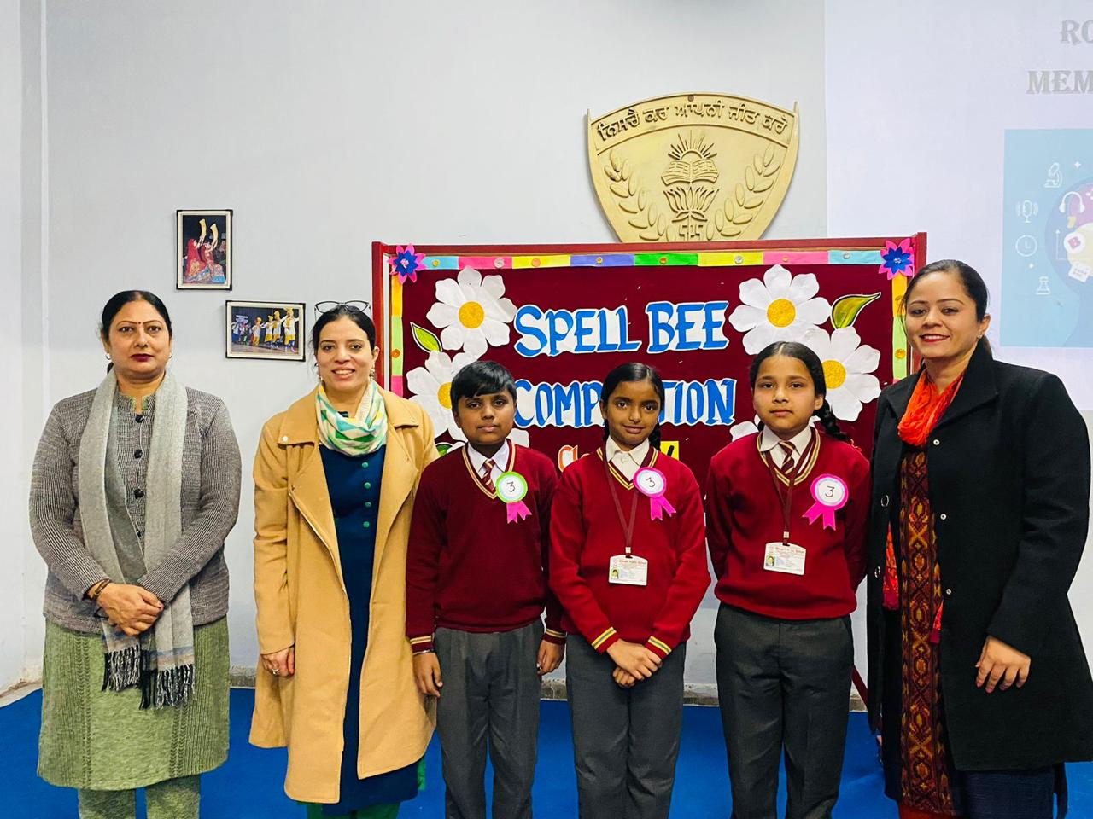
Inter-section Spell Bee Competition for class V was conducted in Shivalik Public School, Phase 6, Mohali. The competition aimed at creating awareness of the possibilities of using varied words in oral and written expression and to add words to the active vocabulary of the students. The competition helped the children to familiarize with the spellings and usage of many unfamiliar words. The quiz was taken in seven different rounds like the pronunciation of the words, ‘the search engine’, ‘brain booster’, picture identification etc. Purvika Garg, Divyansh and Divyajot of Class V-S and Nishika, Anshika and Harleen Kaur of class V-M stood first and second respectively. School Vice Principal, Dr. Teena Chopra crowned the winners. She motivated and appreciated the endeavour put in by teachers and students. She laid emphasis on the four skills namely listening, speaking, reading and writing.

