PRESS RELEASE
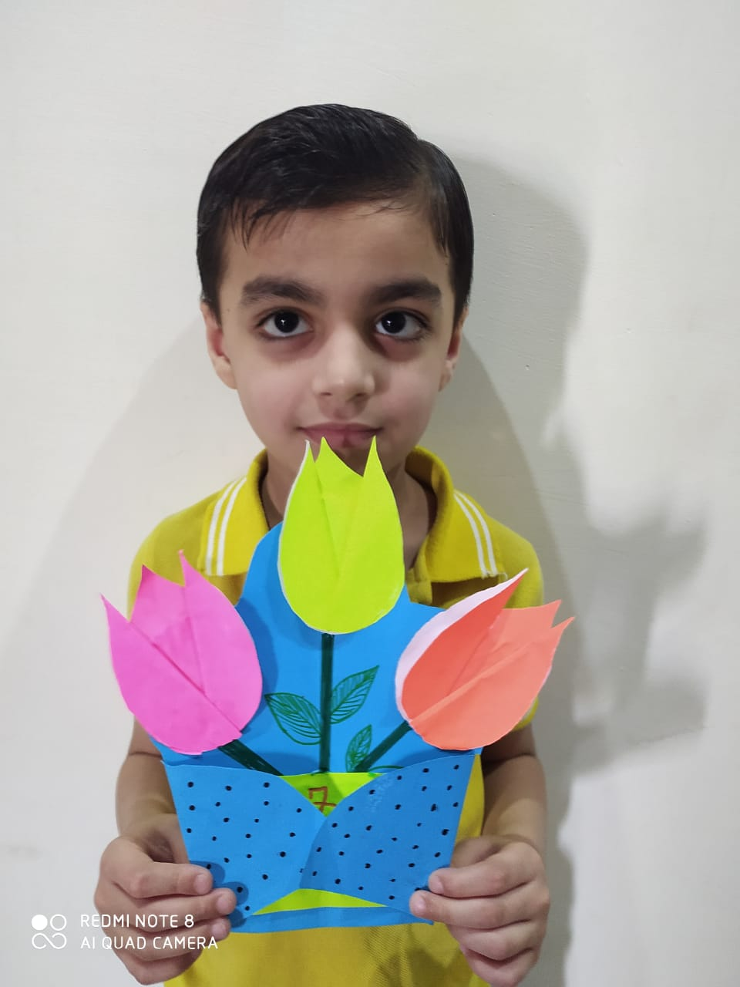
“ Learning is pleasurable but doing is the height of enjoyment”. With the same spirit Shivalik Public School organized Enrichment and Engagement Activities for classes 1 and 2 in an online scenario. It included subject enrichment activities, yoga, music, moral values, clay modelling, life skills, dancing, reading, drawing , craft and so on. Students participated whole heartedly and enjoyed learning by doing these activities. The purpose behind these activities was to encourage kids to explore, experiment and learn independently through activity based techniques. They acquired knowledge outside the academic world. The parents appreciated the efforts made by their teachers. Principal Ms. Anupkiran Kaur applauded the efforts of students as well as teachers . She further added that such type of activities must be taken in future too.

