SHIVALIK PUBLIC SCHOOL,MOHALI
“EARTH DAY”

Earth Day is celebrated on April 22 every year to reminds us of our responsibility to protect our planet.
The students of classes I and II of Shivalik Public School,Phase-6,Mohali celebrated ‘Earth Day’.
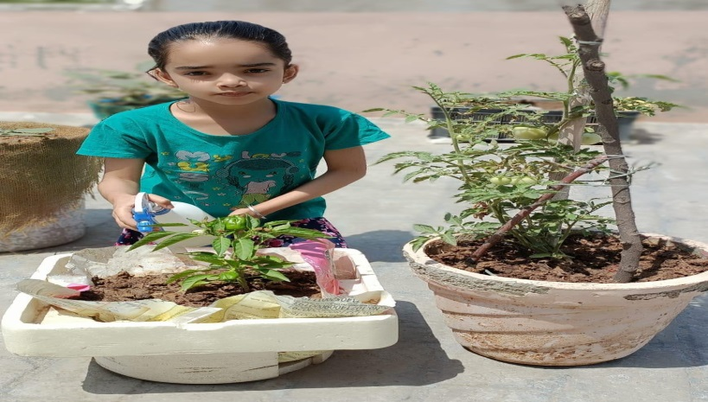
Students participated in ‘Seed Germination’ activity on the theme- “Each one, Plant one” and Drawing activity was also organised on the Theme – ‘STAY HOME ,SAVE EARTH'.
Students were shown a power point presentation on the ways to save earth.
Principal Ms. Anupkiran kaur appreciated the efforts of tiny tots and said “We should remember each day of what we receive from our mother earth and respect her contribution in our lives. Earth is our mother and we should not mistreat her.”

