SHIVALIK PUBLIC SCHOOL
MOHALI
WORLD NATURE CONSERVATION DAY
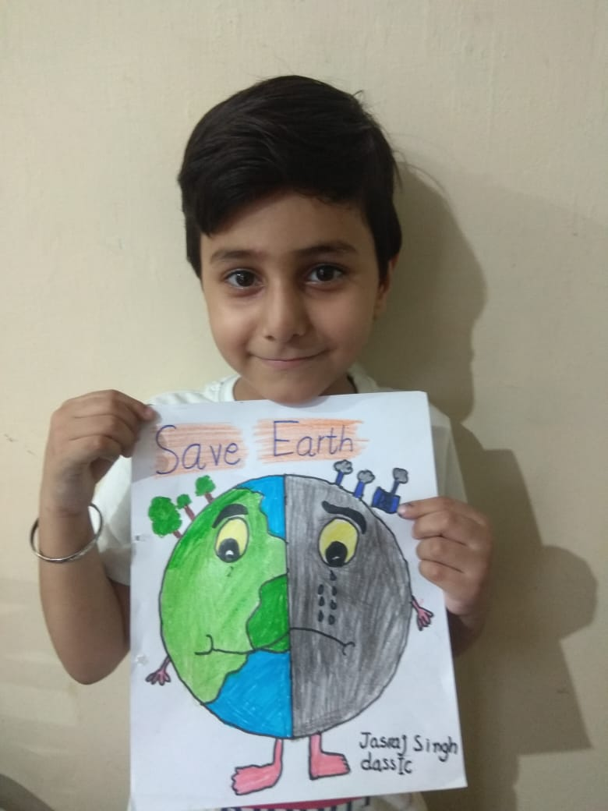
The students of classes I and II of Shivalik Public School ,Phase-6,Mohali celebrated World Nature Conservation Day. A drawing activity was organized on the theme “ SAVE ANIMALS-SAVE NATURE” for class-II and “ SAVE WATER” for class-I. All the students participated enthusiastically. A power point presentation on the importance of earth and how to conserve the nature was shown and explained to kids. The importance of three R’s (reduce, reuse and recycle) was explained to kids through animated videos. Principal Ms. Anupkiran kaur appreciated the efforts of tiny tots and further added that such activities would be a unique platform for enhancing their creativity.

