PRESS RELEASE 2020

REPORT National Doctors’ Day celebrations.

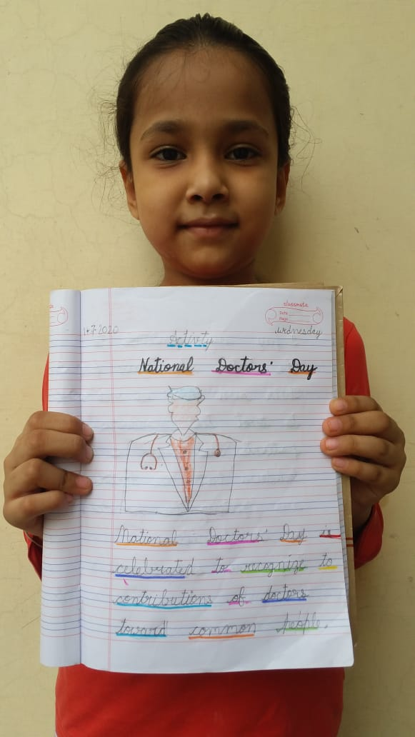
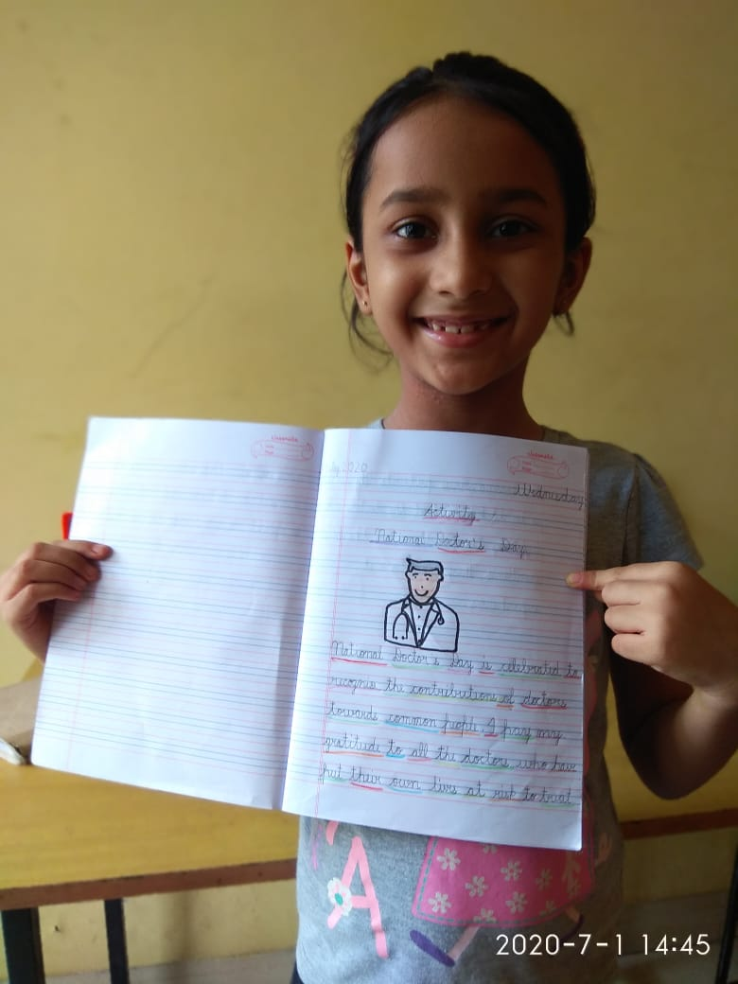
National Doctors’ Day was celebrated in ‘SHIVALIK PUBLIC SCHOOL’ on July 1, 2020 through online classes by the students of classes 1 and 2 to pay tribute to all Doctors’ of the world. The students were shown a video to appreciate all medical personnel of the world for fighting against corona pandemic to save human race. Students also enjoyed a powerpoint presentation shown by the teachers to explain about the various equipments used by the doctors. They were also told about the medical vocabulary such as pills, syringe, wheelchair etc. Students also performed an activity and drew a picture of a doctor and wrote a few lines on our COVID 19 warriors who are fighting on the frontline so that we all can stay in our houses safely.
