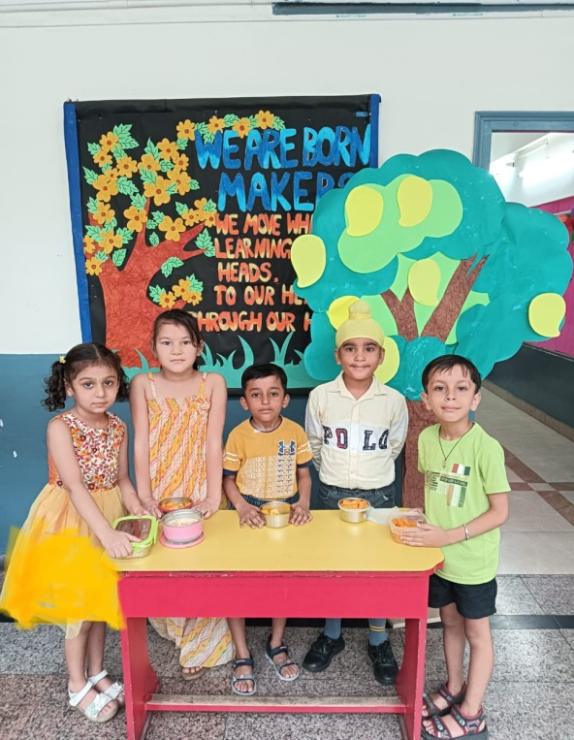
Students of classes I and II at Shivalik Public School, Mohali celebrated ‘The Mango Day’ in the school premises. To depict the importance of yellow colour and to acquaint with the benefits of delicious mangoes was the aim behind such activity. Students came dressed up in the shades of yellow and brought mango in various forms like desserts, cakes, yogurt made from mango in their tiffin box.
Presentations on the usage and types of mangoes was showcased. Drawing activity was also conducted. Principal Dr. Mrs. Anupkiran kaur appreciated the efforts of the students and further added such activities provide a unique platform to enhance their knowledge.

