**Shivalik Public School ,Mohali celebrates  India's  Sovereignty**

***Freedom in the Mind,***

***Faith in the words …***

***Pride in our souls …***

***Let’s salute the nation on this auspicious day***

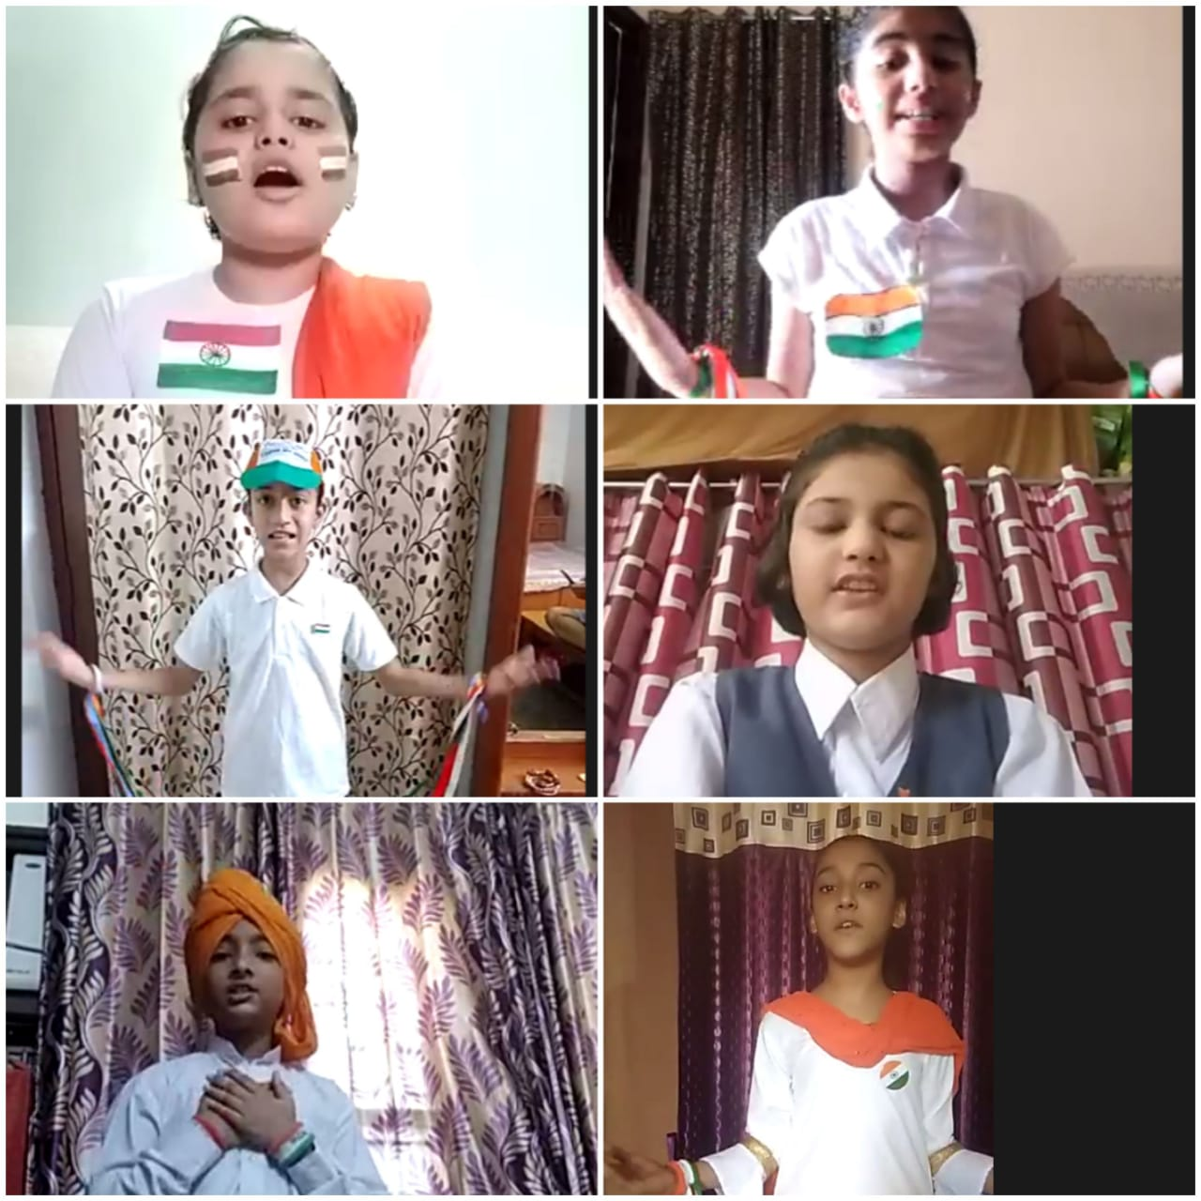Shivalik Public School, Mohali celebrated the 74th Independence Day of India with great zeal and exhilaration. Students all geared up with patriotic fervour shared enlightening speeches, poems, patriotic songs and role plays creating a euphoric ambience. Even the pandemic could not cease the spirit of patriotism as the students of Shivalik Public School recreated the through E –assembly where glimpses of the glory and freedom struggle of India were presented through a plethora of performances including patriotic dances, poetic recitations, role plays and songs. This rekindled the spirit of nationalism in every heart . Everyone seemed to be swayed away in the mixed emotions of joy, hope and pride.Blooming buds of the school lent a rip- roaring flavor when they potrayed themselves as the great freedom fighters virtually ,whereas literary items reflected the feelings in a sought after yet relevant manner.Class 1 and 2 students organized drawing activities for making the National Flag and National Symbols . Powerpoint presentation showing role of freedom fighters were also showcased.  Everyone seemed to be swaying in the mixed emotions of joy, hope and pride.

Most memorable moments were marked by golden words of advice and motivation by worthy Principal Mrs. Anupkiran Kaur. She appreciated the efforts of the students and teachers. Director, Shivalik Public Schools, Mr.D.S. Bedi commended the combined efforts of the students and teachers for presenting the wonderful virtual show and emphasized the need of maintaining peace and communal harmony in the nation in this delicate situation of Covid -19 .

 The celebrations culminated with the National Anthem and a message for the students to act as responsible citizens and future leaders of the nation.

Indeed, it was a day of joy, a day to love and respect our country and make it a better place to live and experience the freedom, peace and unity in diversity.

**Jai Hind**

**Stay safe**