Press Release “National Doctor’s Day”

“Medicines cure diseases but only doctors cure patients.”
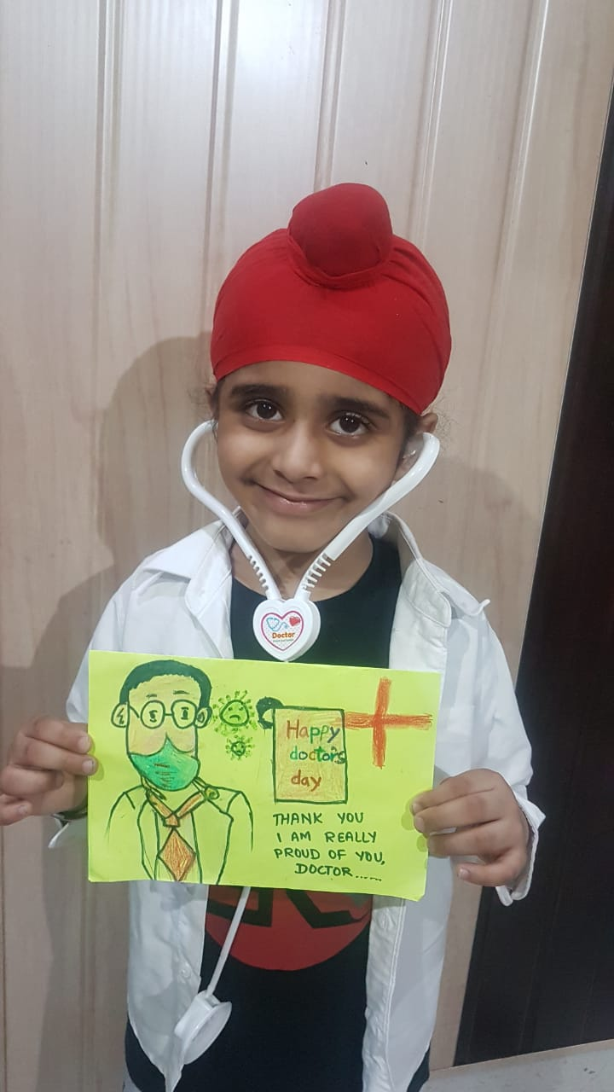
Today in order to pay tribute to all the doctors of the world, the students of classes 1 and 2 of Shivalik Public School, Mohali conducted a drawing activity based on the theme “Gratitude to the Corona warriors”. A video to appreciate all medical personnel of the world for fighting against pandemic to save the human race was shown.The main objective behind this activity was to create awareness among the students.

