REPORT ON CONSTITUTION QUIZ
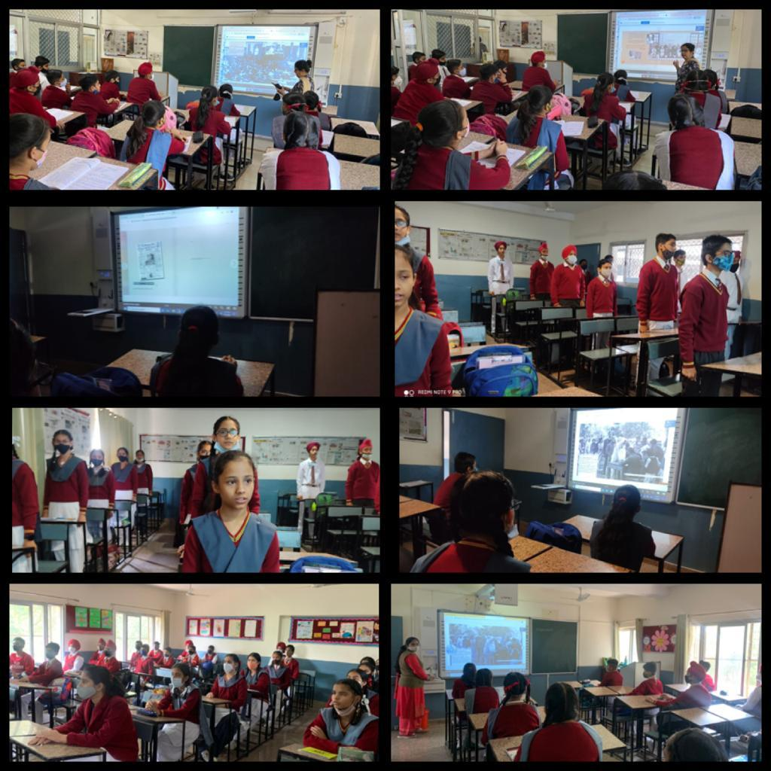
As a part of celebration of Azadi Ka Amrit Mahotsav, Shivalik Public School, Phase VI, Mohali conducted an e-Exhibition on ‘Making of the Constitution’. This e-Exhibition contained rare archival pictures and embedded audio/video relating to the making of the Constitution. An online quiz on this e-Exhibition was also part of it. Link of the quiz was shared with the students. They were shown the videos and pictures related to the constitution. An audio speech of Dr. B R Ambedkar was also shared with the students.

