WORLD FOOD DAY
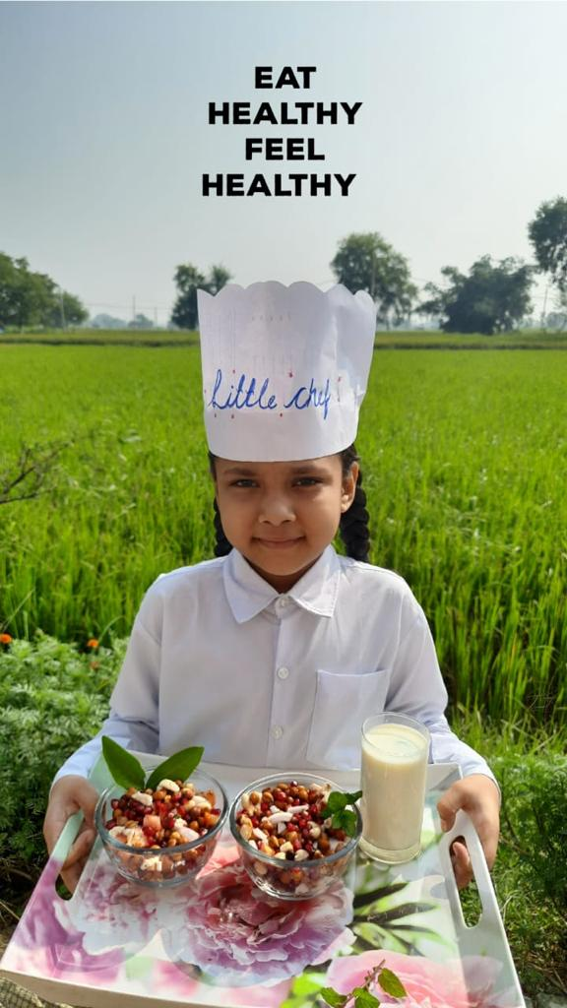
To create an awareness about healthy food students of class I and II of Shivalik Public School, Mohali organized fireless cooking activity on World Food Day.
Children prepared a variety of mouth watering and delicious dishes like Sandwiches, Biscuit cakes and showcased it during the online classes.
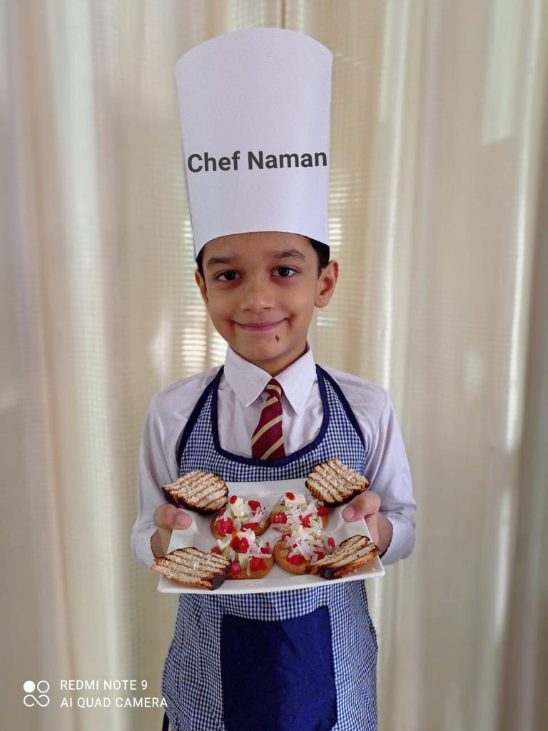
Students were made aware about the importance of the food and encouraged them not to waste it.
It was a unique experience for the young learners as an innovative way of cooking without using fire was added in students’ knowledge.
Addressing the students Principal Mrs. Anupkiran Kaur lauded the efforts of the students and congratulated them for their active participation and commendable presentation.

