**WORLD BOOK DAY CELEBRATIONS**

*A book is a dream you hold in your hands.*

*A reader lives thousand lives before he dies*

*The man who never reads lives only one.*

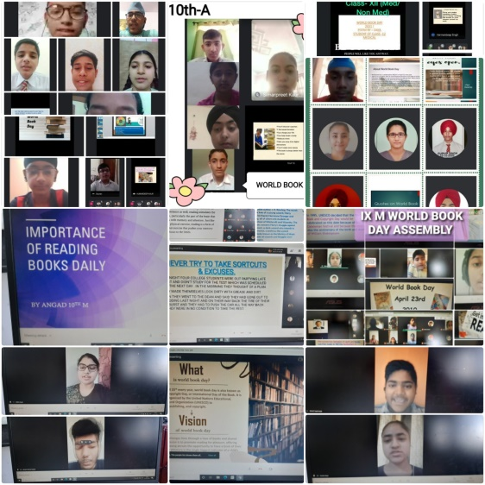World Book Day aims to encourage children to explore the pleasures of books and reading as a book opens a window to the world giving an opportunity to live thousands of experiences and visit myriad places through its pages. Shivalik Public School, Phase VI, Mohali also took the initiative to celebrate the World Book Day through a series of activities planned under the WORLD BOOK WEEK CELEBRATIONS for the students while acquainting the students with the colourful world of books. 23rd of April marks the birth and death anniversary of the greatest writers of all times William Shakespeare and the Spanish prodigy Miguel De Cervantes and many famous authors of all times, thus it was chosen to be celebrated as the WORLD BOOK DAY commemorating the most invigorating , passionate works of art written in history.

Special assemblies were conducted wherein students shared famous books, quotes and characters from their favourite books. Students took this day as an opportunity to share their self-composed poems and stories. The week long celebrations included competitions like book marks, book cover making, slogan and summary writings, character descriptions, quizzes, poetry and story writing which the students actively participated in. The students were thrilled by the fun activities. The school Principal Mrs. Anupkiran Kaur encouraged the students to develop reading habits and appreciated students’ efforts.