Teachers’ Day Celebrations At Shivalik Public School, Mohali
Mohali, 4 September,2020
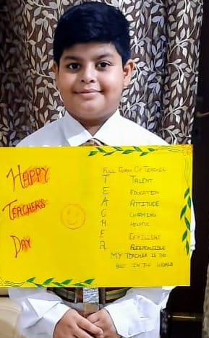
“Teachers are the backbone of any country, the pillar upon which all aspirations are converted into realities. ”
The students of Shivalik Public School, Mohali ensured to make the day special for the teachers even in the midst of the pandemic reaching out through online portal. To celebrate this pious occasion where the teacher, a second mother to a child, is thanked and the spirit of teaching earns appreciation and accolades by means of special efforts put up by the students in the honour of them. The day was initiated with the special assembly wherein the students paid tribute to Dr Sarvapalli Radhakrishnan through power point presentation .Students presented poems ,speeches and songs to showcase their gratitude towards teachers. It proved to be quite interesting and fruitful exercise which was enjoyed by the teachers as well as the students.
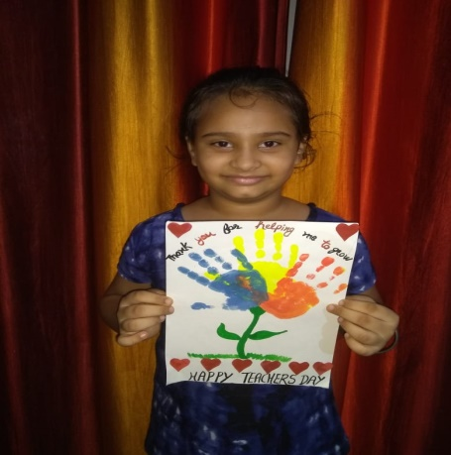
.
Appreciating the efforts of the students in organizing all the events, the Principal, Mrs Anupkiran Kaur, while quoting an example of selfless and humble Dr Radhakrishnan, championed the essence of educators who ignite the intellect and amplify the prospects of future millennium. She commended the students for their impeccable special role performances as the teachers.
The Revered Director, Shivalik Public Schools, Mr D S Bedi , emphasized on discipline, simplicity and amassing knowledge, he conveyed his vision of achieving even better with every passing year in every situation. The message of the Director, Shivalik Public Schools rejuvenated the teachers to feel bound to the noble profession even in this pandemic situation .

