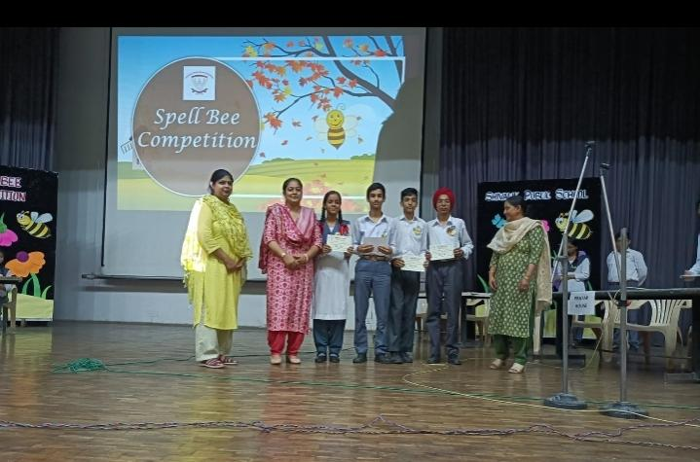**SPELL BEE COMPETITION**

Language plays an important role in all round development of a student. Appropriate words with correct spellings convey the right message. “Spelling is important because it aids in reading. It helps cement the connection that is shared between sounds and letters.”  
The Spell Bee Competition at Shivalik Public School, Phase 6 Mohali, is conducted to give students a platform to learn spellings in different ways, enrich their vocabulary, learn concepts and develop the use of correct pronunciation.  
Preliminary round for the Spell Bee Competition was conducted on 14th July, 2022 for Class IX. The final Inter- House Spell Bee Competition was organized on 21st July, 2022, in the school auditorium. The rounds for the competition were as follows:

* Round I: Names of Countries
* Round II: Personality based vocabulary
* Round III: Food and Travel vocabulary
* Round IV: Picture round (Poets and Authors)
* Round V: Rapid fire (Jumbled words)
* Round VI: Audience round

There were four participants from each house and the winner house was Azad house and first runner-up was the Partap house. The competition was successfully conducted under the support and guidance of the Principal Madam Dr. Anupkiran Kaur. Students were motivated by the Principal as they participated with great enthusiasm and duelled through the toughest words. This competition was a wonderful learning source not only for the participants but also for their peers. The competition helped in enriching the vocabulary bank of the students.

