Road safety week
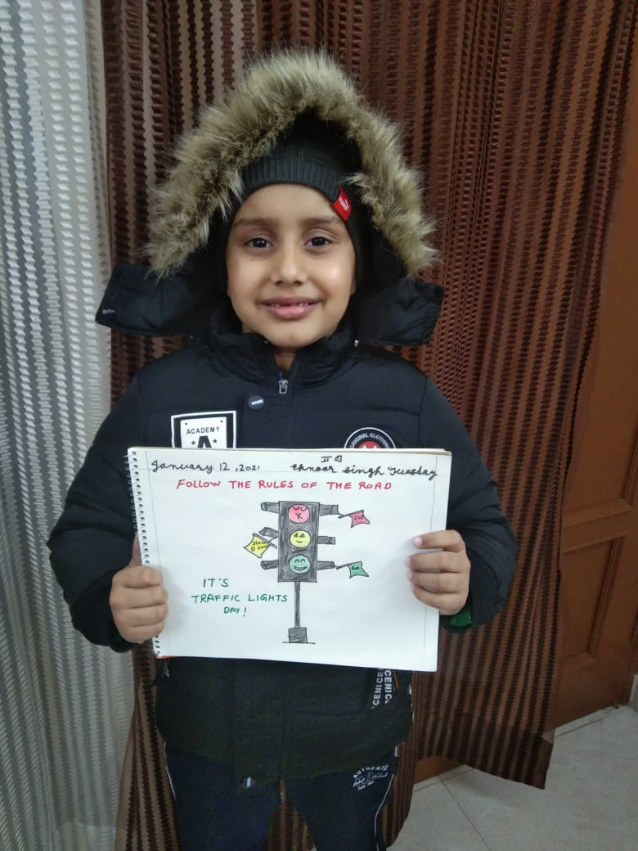
The students of class I and II of Shivalik Public School Mohali marked Road Safety Week with the aim that the children should have a better understanding of their own safety as a pedestrian and ways that they can keep themselves and others safe. A video on ‘Road safety lessons for children’ was shown to the young learners. A power point presentation on road signs for drivers and pedestrians was presented followed by a quiz . The event marked an active participation by the kids. Students also drew the picture of traffic signal with visual indicators.
Principal Ms. Anupkiran Kaur appreciated the efforts and emphasized more on such activities as it would help in building responsible citizens.

