Raksha Bandhan Celebration
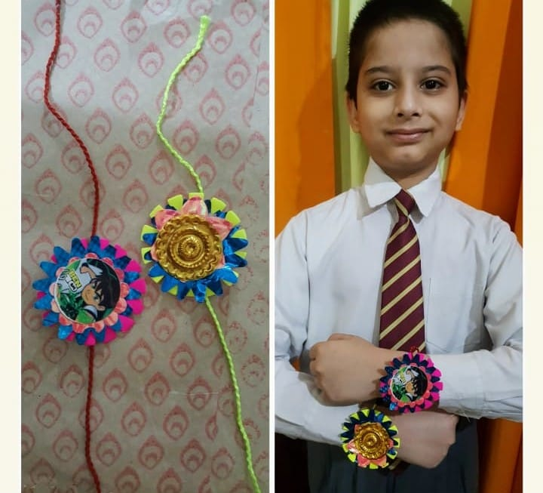
Raksha Bandhan is a special occasion to celebrate the virtuous bond of love between a brother and a sister. To strengthen this bond Shivalik Public School, Phase 6, Mohali, conducted a ‘Rakhi Making’ competition for the students of classes III to V. Due to covid-19, students participated in the Rakhi making competition from their homes with full enthusiasm and zeal.
Children made attractive, colourful and beautiful rakhis using decorative silken threads, ribbons, stars, mirrors, pearls and flowers. Their artisanship was quite fascinating and children thoroughly enjoyed this activity from their home.
The principal Ms. Anupkiran Kaur appreciated the work of the students. She believes that such celebrations of festivals with true spirit teach students about the rich culture and traditions of India.

