SHIVALIK PUBLIC SCHOOL, MOHALI CELEBRATES ITS 55TH FOUNDER’S DAY, BAISAKHI & DR. B.R. AMBEDKAR JAYANTI WITH GRANDEUR

Shivalik Public School, Mohali, marked a momentous occasion by celebrating its 55th Founder’s Day in conjunction with the vibrant festival of Baisakhi and Dr. B.R. Ambedkar Jayanti. The day was a powerful blend of reverence, cultural expression, and institutional pride, offering a rich educational experience for all Shivalikians. 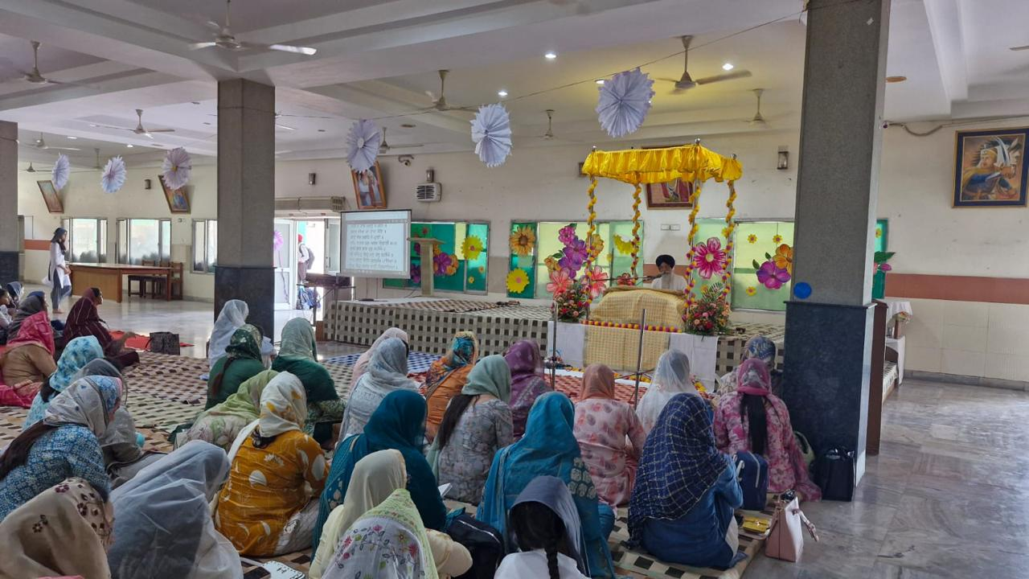The celebrations commenced with a spiritual ambience through the recitation of Sukhmani Sahib Path, followed by soulful Shabad Kirtan and Kavishri, accompanied by insightful explanations from the faculty.The occasion honored Baisakhi not just as a harvest festival but also highlighted its historical importance—especially the formation of the Khalsa Panth by Guru Gobind Singh Ji and the remembrance of the Jallianwala Bagh massacre.

The cultural segment unfolded in the school's modern auditorium with an impressive lineup of performances including speeches, poetic recitations, and themed PowerPoint presentations. These highlighted both the spiritual and historical essence of Baisakhi and the legacy of Dr. B.R. Ambedkar, the architect of the Indian Constitution.

A heartfelt English ode to Shivalik expressed the pride and affection of students towards their alma mater. Energetic and graceful dance performances by students added vibrant color to the celebration, representing the joyous spirit of Baisakhi. A teacher’s talk on the cultural and social importance of the festival brought further depth to the event.

A moving tribute was paid to the founder, Mr. D.S. Bedi, whose vision and dedication were instrumental in shaping the institution’s journey over the past 55 years."

Faculty members from Shivalik Institute of Education and Research also participated, joining in the reflection of the school's rich history and growth.

The event concluded with an inspiring address by the Guest of Honour, Dr. Gurkiranjeet Kaur Nalwa, Principal of Sector 41, Chandigarh. She emphasized the importance of preserving cultural values while striving for academic excellence and encouraged everyone to uphold the school's legacy of integrity, learning, and unity.

The day's proceedings were a true testament to the school’s commitment to holistic education—blending tradition with modernity, reverence with joy, and history with vision.