PRESS RELEASE GANDHI JAYANTI
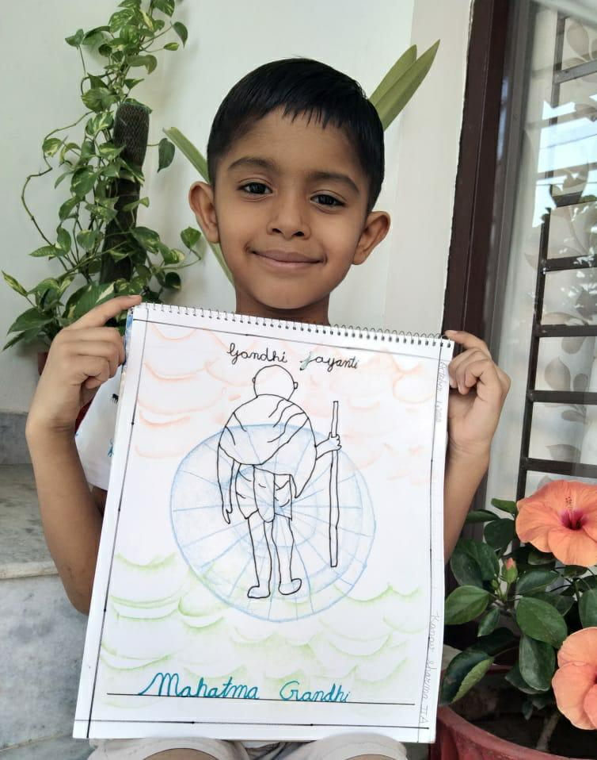
The students of classes I and II of Shivalik Public School Mohali celebrated Gandhi Jayanti with great zeal and enthusiasm. The students were given a brief talk on Gandhi ji’s principles of truth and non-violence. Students drew a picture and wrote few lines on the life of Mahatma Gandhi to pay tribute to the father of the nation who preached peace, truth and non-violence and finally achieved India’s independence.

