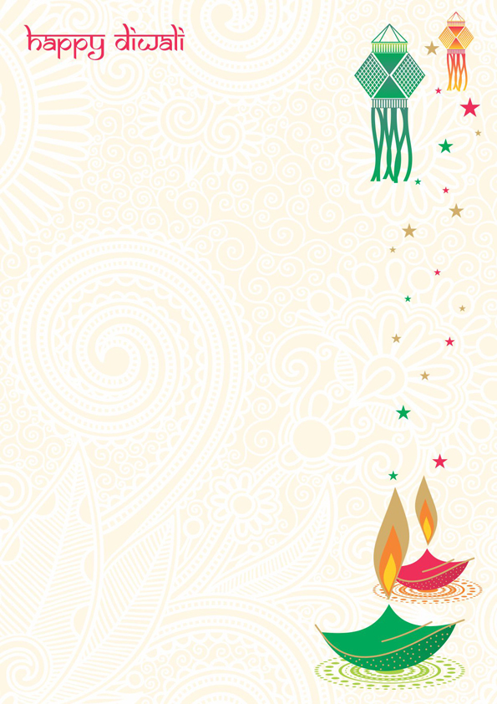

**SHIVALIK PUBLIC SCHOOL, MOHALI**

**CLASS II**

**ACTIVITY PLANNER OF NOVEMBER**

**Greetings from Shivalik Public School!**

The season of festivities and wonder is waiting for you to unwrap joy and gaiety. May the light of the Diwali lamps fill your life with success, happiness and joy.

**November 10,2020 –** Diwali Craft Activity.

**Nobember11,2020 –** Children’s Day Celebration.

**November13,2020 –** PPT will be shown on “Why do we celebrate Diwali”.

**November27,2020 –** Gurupurab Celebrations.

**Show and tell activity** will be conducted inDecember.The theme will be ‘**Home Appliances’**.

**Date sheet of Unit Test 3**

|  |  |  |
| --- | --- | --- |
| **21 – 11 – 2020** | **Saturday** | **English Oral** |
| **23 – 11 – 2020** | **Monday** | **Punjabi** |
| **28 – 11 – 2020** | **Saturday** | **Hindi** |
| **02 – 12 – 2020** | **Wednesday** | **Hindi Oral** |
| **05 – 12 – 2020** | **Saturday** | **English** |
| **07 – 12 – 2020** | **Monday** | **Maths** |
| **12 – 12 – 2020** | **Saturday** | **Art / Craft** |



**SYLLABUS FOR UNIT TEST 3**

**ENGLISH UNIT 6 & 7**

Lesson- 13: 'On my Blackboard I am Draw' (Poem)

Lesson- 14: Make it shorter.

**Vocabulary**: Change the Gender (he, father, boy, brother, king, uncle)

* Use of Mr. and Mrs. (page 93) and 101
* Use of homophones (sea-see, pear-pair, tail-tale, son-sun, two- too)
* Vocabulary on pages (108, 109)
* Write the comparative forms of given adjectives by adding - er (page 113)

**CREATIVE WRITING**

* Make sentences: blackboard, draw, windows, minister, order, wide, bright, marigold, tall, house
* Write five lines on 'My Family'.

**GRAMMAR**

* Describing words.
* Vowels (a,e,i,o,u )

**MATHS (Unit 6 & 7)**

* Lesson 9: My Funday
* Lesson 10: Add our points
* Multiplication Tables of 6 and 7



**HINDI (Unit 6 &7)**

पाठ 9:बुलबुल

पाठ 10:मीठी सारंगी

वाक्य बनाओ – चिडिया, पूँछ, आवाज़, घोंसला, फल, पेड़, गाँव, घर, गाना, मीठा

लिंग बदलो– राजा, मोर, राजकुमार, आदमी, बैल, माता, भाई, मोर, दादा

समानार्थक शब्द - हवा, पेड़, पानी, हाथ, जंगल ,माँ

**Vocabulary**-

* कलगी वाले पक्षियों के नाम लिखो |
* हमें पहचानो (pg -54)
* अनेक शब्द के लिए एक शब्द (pg-54)
* तार वाले, थाप वाले, अन्य संगीत के बाजों के नाम लिखो| (pg-60)
* सही मात्रा लगाओ | (pg-61)
* मीठी, खट्टी और कड़वी चीजों के नाम लिखो | (pg-61)

**PUNJABI**

UNIT-6 • ਤ ਤੋਂ ਨ ਤੱਕ ਪਛਾਣ ਕਰ, ਅਖਰ ਲਿਖੋ |

UNIT-7 • ਪ ਤੋਂ ਮ ਤੱਕ ਪਛਾਣ ਕਰ, ਅਖਰ ਲਿਖੋ |