PRESS RELEASE
DUSSEHRA CELEBRATIONS
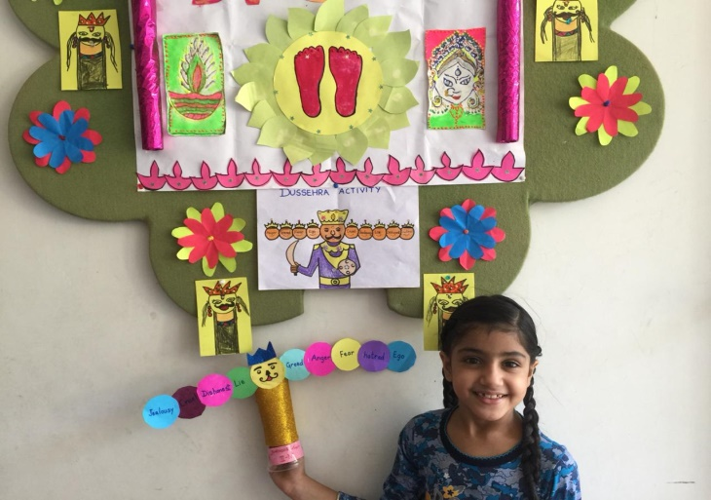
Keeping the festive spirit alive, to mark Lord Rama’s victory over Ravana and to reinforce that good always triumphs over evil, online special assembly on Dussehra for classes 1 and 2 was conducted. Presentation on the importance and cultivation of values through Dussehra was showcased. Craft activity using origami sheet, glossy paper and ice cream stick was demonstrated. Craft activity was based on the ten headed Ravana displaying ten different demons. Students were encouraged to follow good values. Students enjoyed and participated in the activity enthusiastically. Principal Ms. Anupkiran Kaur appreciated the efforts and inspired students to follow the path of goodness.
