“REIMAGINING MATHS THROUGH MANIPULATIVES”

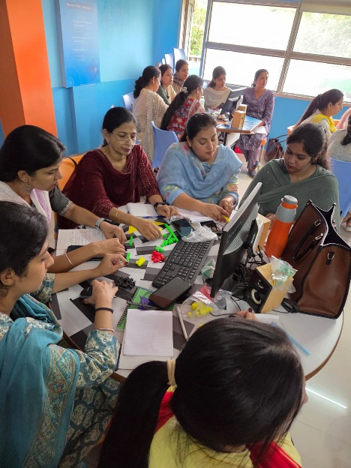An enlightening orientation program on Mathematics was conducted recently, aiming to revolutionize the way math is taught and learned across grades I to X. The session placed a strong emphasis on innovative teaching methodologies through the use of over 35+ virtual and physical math manipulatives, out of which 20 were demonstrated and taught in detail to the attending educators.

The session was skillfully facilitated by Mr. Bhavishya, an expert in mathematics education and hands-on learning. All math teachers and mother teachers from the institution enthusiastically participated in this 5-hour-long session, walking away with fresh insights and practical tools to enhance classroom engagement.

The program covered both offline and online activities, equipping teachers with the knowledge to make abstract mathematical concepts more concrete and relatable. Manipulatives such as tangrams, fraction bars, integer counters, geometric tiles, and algebraic identity tools were used to illustrate critical topics including multiplication, division, area and perimeter, rational numbers, fractions, algebraic identities, integers, LCM and HCF, among others.

One of the key takeaways from the program was the focus on visual learning. With manipulatives, children will no longer fear math—they will experience it. Concepts that were once daunting, such as multiplication tables or algebraic identities, will now be visualized and understood through interactive tools and activities, reducing rote memorization and increasing conceptual clarity.

Teachers were deeply appreciative of this new approach and are now equipped to implement these strategies in their classrooms, making mathematics an engaging and fear-free subject for every learner.

This orientation marks a significant step toward transforming mathematics education into an experience of discovery, understanding, and joy.