PRESS RELEASE BLUE DAY
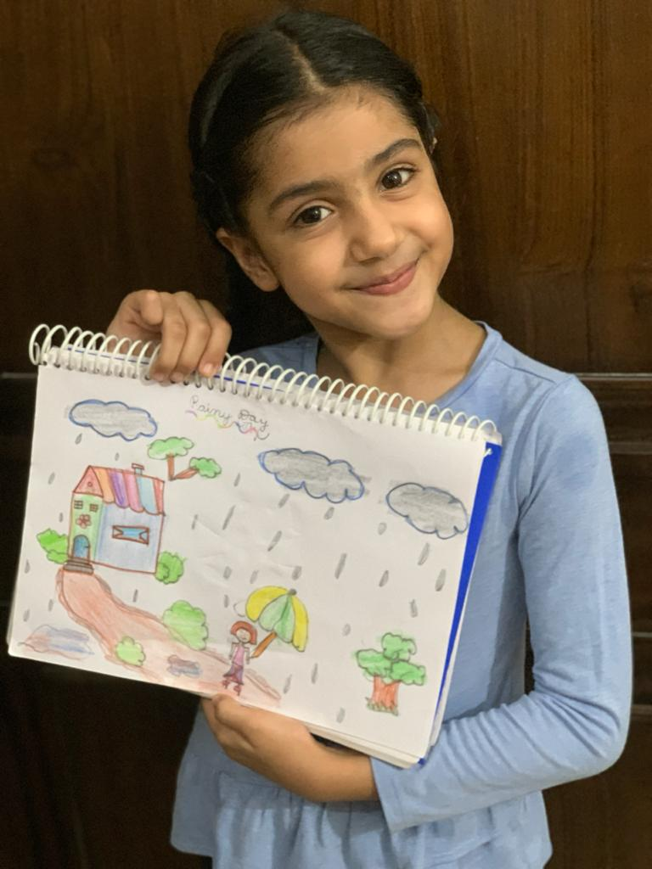
The students of classes Ist and IInd of Shivalik Public School, Mohali celebrated Blue Day on 20th July , 2020. All the children were dressed up in different shades and hues of blue. Drawing activity was organized for the children on the theme - ‘Rainy Day’. Craft activity (Paper boat making) was demonstrated by the teacher in the online classes, students followed the teacher and participated enthusiastically. They also recited poem on “Rain” with their teachers. A PowerPoint Presentation on the importance of water and how to conserve it was shown and explained to the kids. Blue the colour of loyalty, wisdom and strength had a very positive impact on the students bringing in harmony and brotherhood. Principal Mrs. Anupkiran Kaur appreciated the effort of the students and further added that these types of activities should be promoted in the future also.

