PRESS RELEASE (Mathematics day)
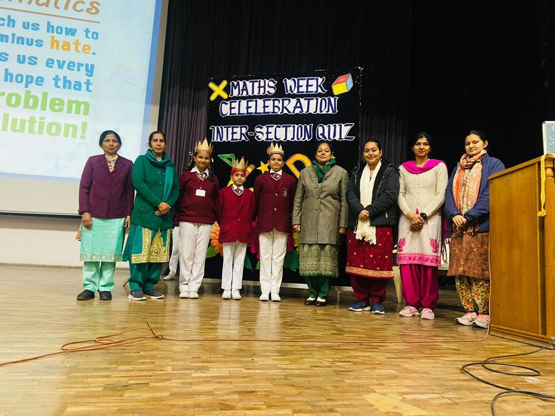
With an aim to enhance the critical thinking and problem solving skills of the students , Shivalik Public School, Mohali, observed week long activities based on inculcating Mathematical skills.
A PowerPoint Presentation was shown to the students related to the contributions made by Shri Srinivasa Ramanujan, the great mathematician genius, who made exemplary contribution to Mathematics. Students of class 3 participated in a Maths Relay Race and even made designs and shapes from the origami sheets. This activity helped them in exploring and identifying shapes in their real life. Rangometery activity was organised for the students of class 4. Under this, the students learnt about Pattern and Shape Recognition and Colour Identification. It even helped the students in boosting their creativity through hands-on learning.
Students of class 5 made Posters to commemorate National Mathematics day and a Quiz competition was conducted for them which challenged their reasoning skills. All the students participated with great zeal and enthusiasm in each and every activity.The mindful participation of students was duly praised by our Principal ma’am, Mrs. Anupkiran Kaur, who culminated the quiz with her motivational words.

