SHIVALIK PUBLIC SCHOOL
PLANNER FOR THE MONTH OF MAY, 2023
CLASS- NURSERY

Work Plan for the month of May.

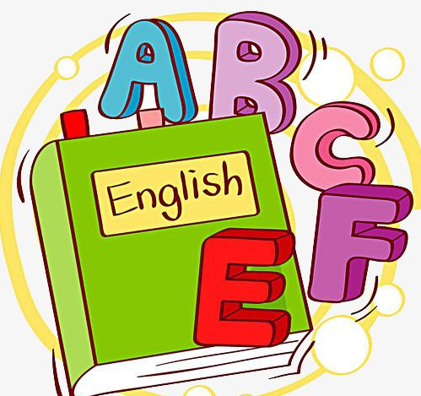
ENGLISH-ORAL(WORLD OF LETTERS)
- Learning patterns (Sleeping line, curve and slant lines)Page number 15 to 19
- Meet the letter A
E.V.S:
- Parts of Body
MULTIMEDIA:
- PPT on Parts of Body
- PPT on fruits

MATHS:
- One for everyone (Page no-10)
- Big and Small (Page no-11)
- Long and Short(Page no-12)
- Sort and Place (Page no-13)
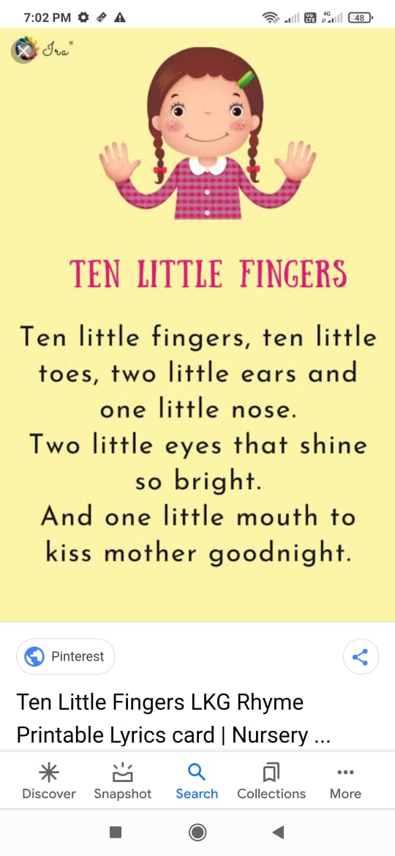

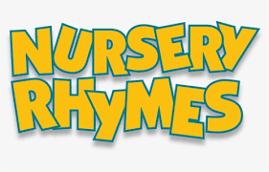

This is the way we wash our hands,
Wash our hands,wash our hands.
This is the way we wash our hands,
So early in the morning.

This is the way we brush our teeth,
Brush our teeth,brush our teeth.
This is the way we brush our teeth
So early in the morning.

This is the way we comb our hair,
comb our hair, comb our hair.
This is the way we comb our hair
So early in the morning.
DRAWING AND CRAFT:
- Free hand Scribbling
- Bud painting
- Cotton dabbing
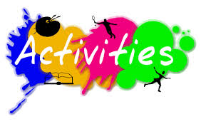

- Worksheet on tracing patterns May 02, 2023
- Hand printing May 03, 2023
- Healthy food competition May 05, 2023
- Making of photoframe May 11, 2023
- Mother’s Day Craft May 12, 2023

- Slate activity May 10,2023
- Clay moulding May 11, 2023
- Colouring in Shapes (Square) May 12, 2023
- Paper folding Square May 15,2023

- Tracing Long and Short lines May 17,2023
- Seed Sorting Activity May 18,2023
- Cotton dabbing in mango May 19,2023
- Bud painting in Pineapple May 22,2023
- Concept of red colour May 24,2023
- Collect object related to letter A May 26,2023

THANKYOU

