**SHIVALIK PUBLIC SCHOOL**

**PLANNER FOR THE MONTH OF JULY,2025**

**CLASS- NURSERY**

**Theme for the month of July: Monsoon Magic**

**Value of the month:- Gratitude for Nature’s blessings.**

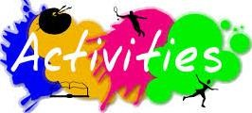

|  |  |
| --- | --- |
| **HAMMERING ACTIVITY** | **09.07.2025** |
| **MAKING OF BUTTERFLY**  **WITH HANDS** | **10.07.2025** |
| **YELLOW DAY( MANGO**  **PARTY)** | **11.07.2025** |
| **COLOURING IN BALL** | **14.0.2025** |
| **PAPER FOLDING**  **TRIANGLE** | **16.07.2025** |
| **LEMONADE PARTY** | **18.07.2025** |
| **MAKING OF CATERPILLAR**  **WITH THUMB PRINTING** | **22.07.2025** |
| **PATTERN WALKING** | **24.07.2025** |
| **SELF INTRODUCTION**  **( INTRA- SECTION)** | **21.07.2025** |
| **SELF INTRODUCTION**  **( INTER- SECTION)** | **23.07.2025** |

# DRAWING-( MY LITTLE ARTIST)

* **B for BALL (Colouring activity)-(Page No-7)**
* **C for CAT ( Colouring activity)- ( page No-8)**

PATTERNS-( WRITING SKILLS)

* Triangle Pattern (Page No- 18,19)
* Square Pattern (Page No- 20,21)
* Ball Pattern ( Page No- 22,23)
* Oval Pattern (Page No-24,25)
* Loop Pattern ( Page No-26,27)
* Spiral Pattern-I (Page No-28,29)
* Spiral Pattern- II ( Page No-30,31)
* Ribbon Pattern ( Page No-32,33)

# ENGLISH-ORAL(WORLD OF LETTERS)

* **Learning patterns (Sleeping line, curve and slant lines)Page number 20 to 25**
* **Meet the letter B**
* **Meet the letter C**

# E.V.S:

* **Places Around Us: ( Page No-22,23)**
* **Good Food (Page No-24)**
* **Off to School (Page No-25)**
* **The Way To School (Page No-26)**
* **My School And I (Page No-27)**
* **I Have Fun In My School (Page No-28)**
* **I Learn In School (Page No-29)**
* **Meet The Colour Yellow(Page No-30)**

# MATHS:

# Shapes around us(Page No-18,19)

# I can make sequence (Page No-20,21)

# Fun with shapes (Page No-22)

# I can spot the difference(Page No-23,24)

# Trace the patterns (Page No- 25 – 27)

# 1 Green Parrot (Page No-28)

# MULTIMEDIA:

* + **PPT on fruits and Vegetables**
  + **Video on Numbers And Alphabets**

# DRAWING AND CRAFT:

* + **Free hand Scribbling**
  + 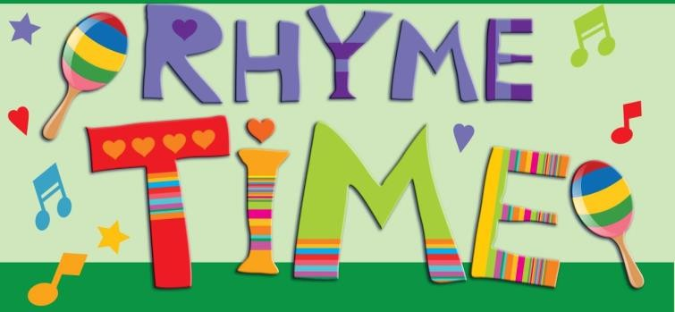**Yellow Day Craft**

**THE TOY TRAIN**

**The toy train takes us on a ride! Shaking, shaking from side to side. Here it comes, Chook, chook , chook, Come and take a look, look, look!**

**So many children out at play! Girls and boys play everyday! We can hop and we can run, Jumping too, can be fun!**

**DRIP DROP**

**Drip Drop the rain is falling down.**

**Drip Drip Drop Drop the rain is falling down.**

**The trees and the flowers are happy in the rain.**

**We can have a good time playing in the rain.**

**STORY (THE COLOUR BOX)**

**Once upon a time, there were two friends, Ria and Rohan. They were good friends. One day, they were drawing. Ria had a big box of colors, but Rohan didn't have any. Ria saw Rohan looking very sad. Then Ria said, "Rohan, you can use my colors." Rohan's face lit up with a big smile. "Oh, Ria, you are so kind for sharing colors with me. Thank you!" They both made a beautiful picture.**

**MORAL OF THE STORY-SHARING IS CARING**