**Orientation Programme Equips Students and Parents for the Year Ahead**

Date: 17 May, 2025

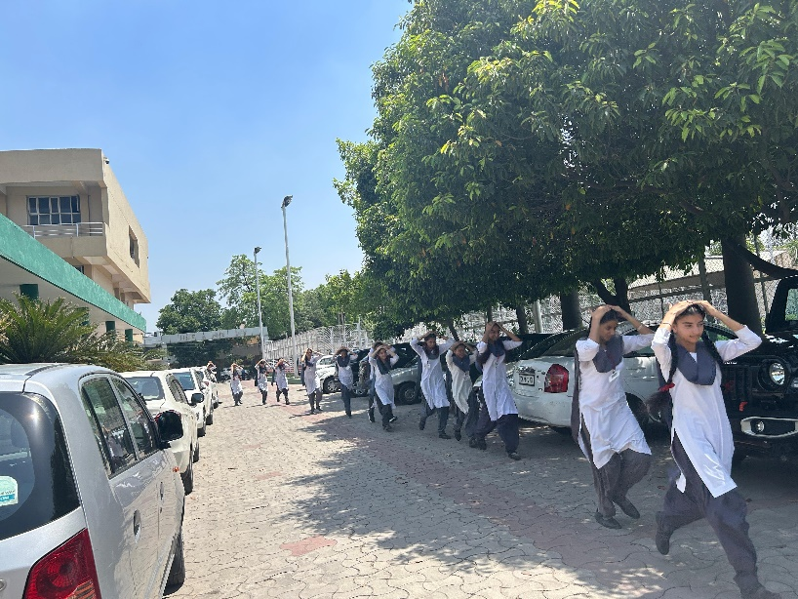To help students and parents begin the new academic year with clarity and confidence, Shivalik Public School conducted an Orientation Programme for Classes IX and X. The session aimed to provide a clear understanding of academic goals, school expectations, and collaborative roles in supporting student success. The programme began with the School Shabad, creating a calm and respectful atmosphere. Key areas such as school discipline, vision and mission, attendance policies, co-curricular activities, and subject combinations—including Standard and Basic Mathematics—were discussed. Parents were also guided through the use of the school app, internal assessments, registration process, and fee-related procedures. The importance of Competency-Based Education and life skill subjects like Information Technology and Physical Education were highlighted as part of the holistic learning approach. The session ended with an inspiring address by the Principal, (Dr.) Anupkiran Kaur, who emphasized the school’s commitment to academic excellence and value-based education. An interactive question-answer round followed, allowing parents to seek clarification and share their feedback. The Orientation Programme served as a strong step in building mutual trust and cooperation between the school and parents, laying the foundation for a productive and meaningful academic journey ahead.