OLYMPIAD ACHIEVEMENTS
SESSION 2020-21
“Success is no accident. It is hard work, preservance, learning, studying, sacrifice and most of all love of what you are doing or learning to do’’
Education and academic competitions are two most important ingredients of human life and these two have always been considered as important issues.
There is no doubt education is secret key of human success and the roots of education lie on competition. A child is born without knowledge and skills, and they continuously participate in competitions in every part of their life, developing skills and knowledge through a learning process. Indeed, without competitions, we cannot imagine education.
Shivalik Public School, Mohali conducts Olympiads every year with an aim to provide a platform to brush the learning abilities of its students over and above the curricular programs.
Once again the students brought laurels by bagging Gold, Silver and Bronze Medal of Excellence in English, Mathematics and Science by Silver Zone Olympiad foundation. In addition, 13 students from Classes VI-XII have been placed on the merit list for their commendable achievement in GK, MATHEMATICS and SCIENCE, which has made everyone proud.
Principal Mrs. Anup Kiran Kaur congratulated the achievers for their whole hearted endeavour and motivated them to excel the pinnacles of success.
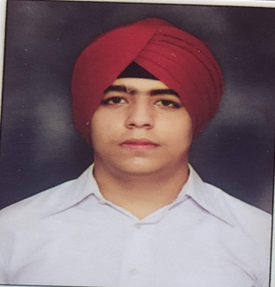
HARPARTAP SINGH
CLASS VIII
(Gold Medal of Excellence in
Mathematics and Science)
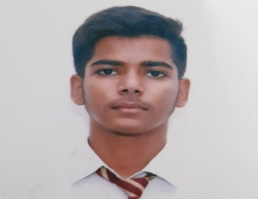

DAKSH
CLASS XII
(Gold Medal of Excellence in Mathematics)

SUSHANT GARG
CLASS VIII
(Silver Medal of Excellence in Science & Mathematics)
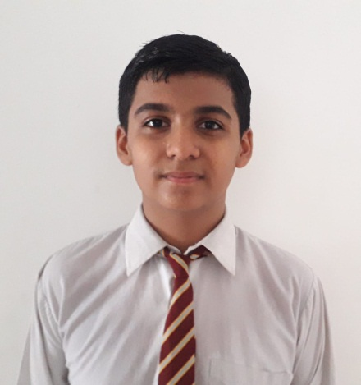

KANAV SAINI
Class VI
Gold Medal of Excellence in English
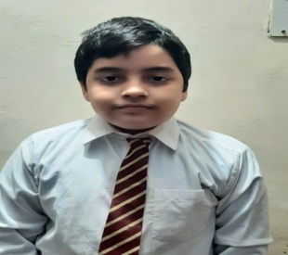
ATULYA SHARMA
Class VI
Gold Medal of Excellence in Science
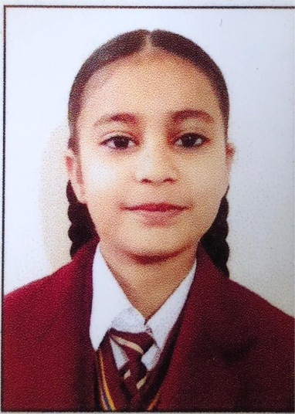
JAPNOOR KAUR
Class VI
Silver Medal of Excellence in Science

SAHIL KUMAR
CLASS IX
(Gold Medal of Excellence in
Science)

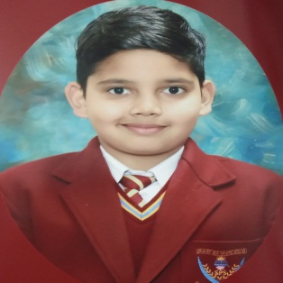
ROOPAM GULERIA
CLASS VII
(Silver Medal of Excellence in
Science)

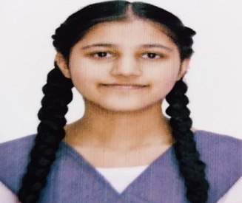
Gursimran Kaur
CLASS VII
(Gold Medal of Excellence in
Science)
Dhruv Mittal
CLASS VI
(Bronze Medal of Excellence in
Science)

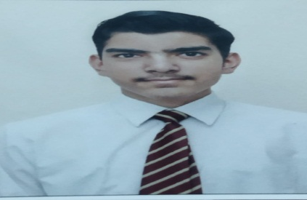
Danish Thappar
CLASS VIII
(Bronze Medal of Excellence in
Science)

