SHIVALIK PUBLIC SCHOOL,
PHASE –VI, MOHALI
PLANNER FOR NOVEMBER- 2025
CLASS- NURSERY

THEME OF THE MONTH
‘Value of Equality and Kindness’

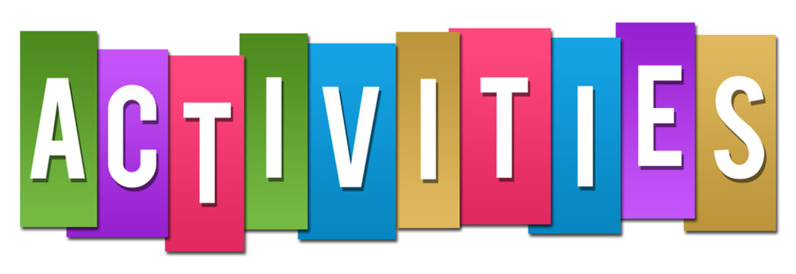
Activity | Date
Colouring and ear bud impression in octopus | 3.11.2025
Visit to Gurudwara | 4.11.2025
Dry pouring | 10.11.2025
Shoe lacing | 12.11.2025
Children day celebration | 14.11.2025
Nature walk | 19.11.2025
Colour sorting | 21.11.2025
Paper folding fish | 24.11.2025
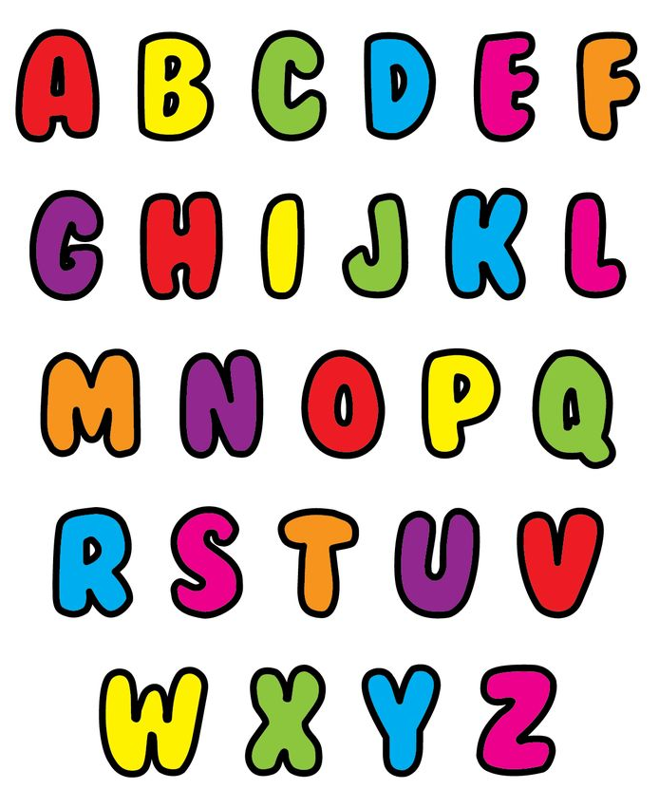
ENGLISH-(WORLD OF LETTERS)
- Picture talk (Page No-63)
- Meet the letter Tt (Page No- 64, 65)
- Meet the letter Uu (Page No- 66, 67)
- Meet the letter Vv (Page No- 68, 69)
- Meet the letter Ww (Page No- 70, 71)
- Making Alphabets with clay
ENGLISH-(WRITING SKILLS CAPITAL LETTERS)
- Patterns (Page No- 2 – 9)
- Letter A (Page No- 12, 13)
- Letter B (Page No- 14, 15)
- Letter C (Page No- 16, 17)
- Letter D (Page No- 18, 19)
- Activity 1 & 2 (Page No- 20, 21)
- Practice writing (Page No- 22,23)
- Letter E (Page No- 24, 25)
RHYMES

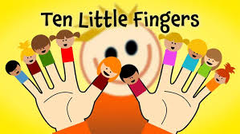
- TEN LITTLE FINGERS
Ten little fingers
Ten little toes,
Two little ears
And one little nose,
Two little eyes,
That shine so bright,
And one little mouth,
To kiss mother goodnight.

STORY (The Boy and Cashew Nuts)
A boy named Joy was very fond of cashew nuts. So, his mother always gave him few nuts to eat. Joy asked for more nuts everyday. One day Joy was alone in the house so he ate many cashew nuts. He fell sick. He had pain in his stomach. He felt sorry for not obeying his mother.
Moral: Always obey your parents.

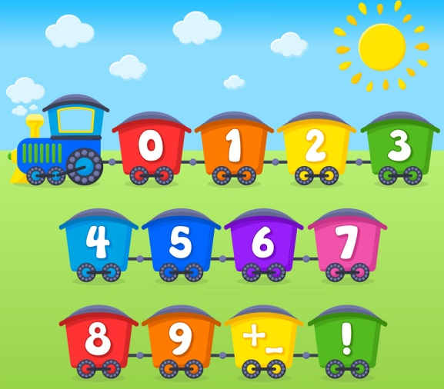
MATHS-(WORLD OF NUMBERS)

- More and less ( Page No- 61)
- 9 Clever pigeons (Page No- 62, 24)
- Meet the number 10 (Page No- 65, 66)
- I can count! (Page No- 67)
- Clay moulding

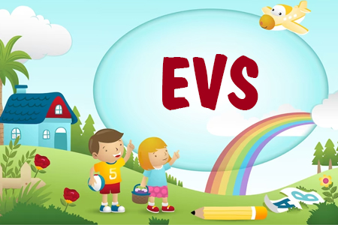
E.V.S
- More fruits (Page No- 53)
- Fun with fruits (Page No- 54)
- I can colour (Page No- 55)
- Animals on the farm (Page No. 56, 57)
- To the farm (Page No- 58)
- Time to listen (Page No- 59)
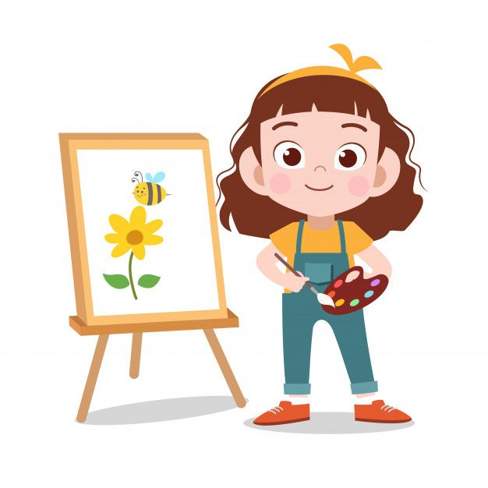
DRAWING-(MY LITTLE ARTIST)
- T for Tortoise (Page No- 25)
- U for UFO (Page No- 26)
- V for Van (Page No- 27)
- W for Whale (Page No- 28)

G.K. QUESTIONS
- SEASONS
Q1. How many seasons are there?
  - There are four main seasons.
Q2. Name the four main seasons.
  - Spring, Summer, Autumn and Winter.
Q3. Which is your favorite season?
  - My favorite season is _________.

E. RESOURCES
- Video on numbers
- Video on kindness and responsibility
- Video of rhymes and winter songs
- PPT on seasons

