SHIVALIK PUBLIC SCHOOL, MOHALI
PLANNER FOR THE MONTH OF FEBRUAURY AND MARCH- 2023
CLASS - NURSERY
ENGLISH-(WORLD OF LETTERS)
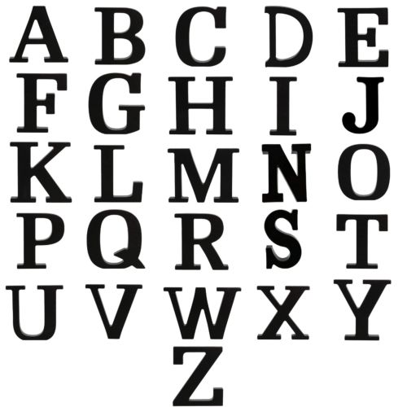
- Meet the letter Xx (Page no-72-73)
- Meet the letter Yy (Page no-74-75)
- Meet the letter Zz (Page no-76-77)
- I can trace! (Page no-80-81)
- Trace and match (Page no-82)
- I can trace! (Page no-83-85)
- Trace and match (Page no-86)
- I can trace! (Page no-87-90)
- Trace and match (Page no-91)
- Listen, find and trace (Page no-92-93)
- Letters Big and Small (Page no-94-95)

RHYME
- UP IN THE BLUE SKY
Up in the blue sky
What do you see
Big birds small birds
Looking at me
Flying flying sha la la la
Flying flying ha ha ha ha

Deep in the ocean
What do you see
Big fish small fish
Looking at me
Swimming swimming sha la la la
Swimming swimming ha ha ha ha

Out in the garden
What do you see
Big flower small flower
Looking at me
Blooming blooming sha la la la
Blooming blooming ha ha ha ha

MATHS(WORLD OF NUMBERS)
- My activity page (Page no-70-71)
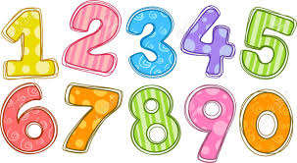
- I can draw! (Page no-72)
- Things that go together (Page no-73)
- I can draw! (Page no-74-83)
- I can trace! (1to 10) (Page no-84-85)
- learning numbers (Page no-86-87)
E.V.S
- Seasons
G.K questions:
1. Who gives us milk?
2. How many months do we have in a year?
3. How many colours are there in a rainbow?
4. Which is the hot season?
5. Which is the coldest season?
6. What do you see in the sky at night?
7. Where do birds live?
8. What clothes do we wear in winter season?
9. What do we wear in rainy season?
10. Give two names of road transport vehicle?
11. In which festival we play with colours?
12. What is the name of our country?

ACTIVITIES
Letter X Craft (01.02.23)
Activity related to concepts (02.02.23)
Worksheet on seasons (06.02.23)
Letter Y (08.02.23)
Count and tell with bud painting (09.02.23)
Letter Z (15.02.23)
Activity-Number tree (16.02.23)
Slate activity (20.02.23)
Making of letters with Ice-cream sticks (22.02.23)
Revision of numbers 1 to 10 (01.03.23)
Revision of shapes (07.03.23)
Revision of colours (10.02.23)
Revision of all rhymes (13.02.23)

PRACTICE OF DEMONSTRATION

