SHIVALIK PUBLIC SCHOOL, MOHALI
PLANNER FOR THE MONTH OF JANUARY- 2021
CLASS- NURSERY
ENGLISH-(WORLD OF LETTERS)
- Meet the letter Tt (Page no-64-65)
- Meet the letter Uu (Page no-66-67)
- Meet the letter Vv (Page no-68-69)
- Meet the letter Ww (Page no-70-71)

RHYMES
- TWINKLE TWINKLE TRAFFIC LIGHTS
Twinkle, twinkle traffic light
Round the corner shining bright
Red means stop, green means go,
Yellow means go, very slow
Twinkle, twinkle traffic light
Round the corner shining bright.
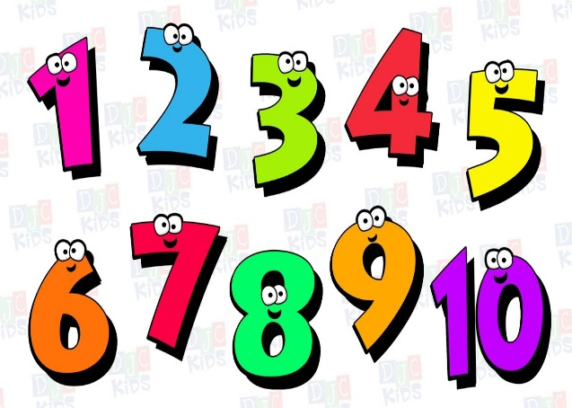
- FLOWERS IN MY GARDEN
Flowers in my garden,
Oh what a fun.
Thank you rain, thank you sun
Yellow and red, pink and blue.
Pretty as me , lovely as you.

MATHS
- Meet the number 10 (Page no-65-66)
- I can count! (Page no-67)
- I can trace! (Page no-68)
- I can match! (Page no-69)

- E.V.S (moral talk on festivals)
- Why do we celebrate Republic Day?
- Why do we celebrate Lohri?
Multimedia
- PPT on Pet Animals and Wild Animals.
DRAWING BOOK (GRAFALCO)
- Colour in ‘A Lollipop “ (Page no-19)
- Colour in “An Umbrella”(Page no-20)
- Colour in “The Mango”(Page no-21)
ACTIVITIES

Craft on letter T (Tulip) (04.01.2021)
Worksheet on Numbers (05.01.2021)
Count and tell with Beads (07.01.2021)
Number activity with Bindi (08.01.2021)
Craft on letter U (11.01.2021)
Craft on Lohri (Basket Making) (13.01.2021)
Sprout Chaat making (15.01.2021)
Craft on of letter V (18.01.2021)
Republic Day Celebration (25.01.2021)
Recognition of Alphabet with flash card (28.01.2021) Clay Moulding (29.01.2021)
Show and tell (Topic: Toys) (30.01.2021)

