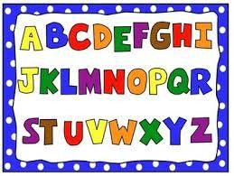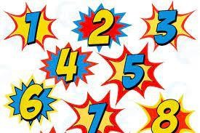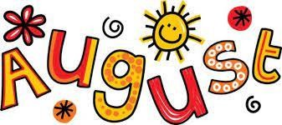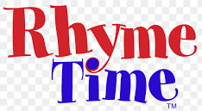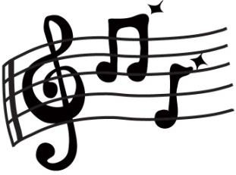SHIVALIK PUBLIC SCHOOL,MOHALI PLANNER FOR THE MONTH OF AUGUST- 2022
CLASS-NURSERY

ENGLISH (World of Letters)
- Meet the letter Ee (Page no-28-29)
- Meet the letter Ff (Page no-30-31)
- I Know A to F (Page no-32)
- Picture Talk (Pageno-33)
- Meet the letter Gg (Page no-34-35)
- Meet the letter Hh (Page no-36,37)

WASH YOUR HANDS
Wash wash wash your hands, get them nice and clean.
Scrub the tops and scrub the bottoms
And don’t forget in between
GOOD MANNERS
We say”Thank you” We say “Please” And “EXCUSE ME”
When we sneeze, that’s the way we do what’s right,
We have a manner, we are Polite.

MATHS (World of Numbers)
- 1 green Parrot (Page no-28-30)
- One and many (Page no-31)

- 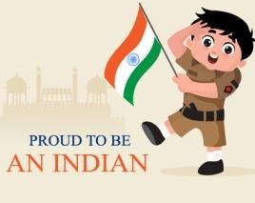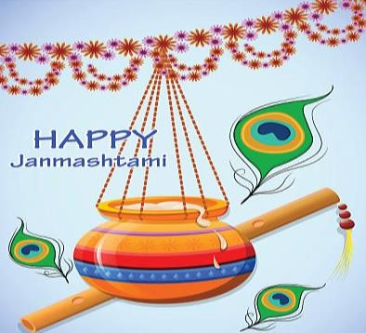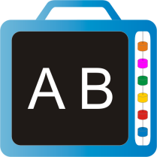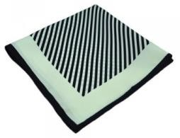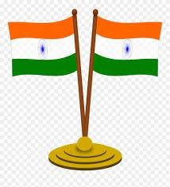Tall and short (Page no-35)
- 2 Naughty Monkeys (Page no-32)
- I know 1,2 (worksheet)
- 3 Bears and Goldilocks (Page no-36)
- I know 1,2,3 ( Page no-39)
- 4 Rabbits and Pluto (Page no-40)
- I know Number 4 (page no-42)

ART AND CRAFT:
- Janmashtami craft -Matki Decoration (worksheet)
- Independence day craft:- Paper Folding
- Clay moulding - Shapes

DRAWING BOOK:
- Scribble with different colours (Page no-12,13)
E.V.S
Q1.Which is the national Animal of India? Q2.Which is the national Bird of India?
Q3. Which is the national Flower of India? Q4.Which is the national Fruit of India?
Q5.Which is the national Tree of India? Q6.Which is the national Song of India?
Q7.How many colours are there in our National flag?
ACTIVITIES
- Clay Moulding (Shapes) (02.08.2022)
- Bud painting in flower worksheet (03.08.2021)
- Handkerchief Folding (04.08.2022)
- Fish ( decorate your fish) (05.08.2022)

- Rakhi Making Craft (10.08.2022)
- Independence Day Celebration (11.08.2022)
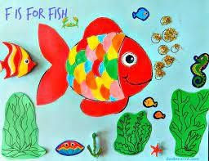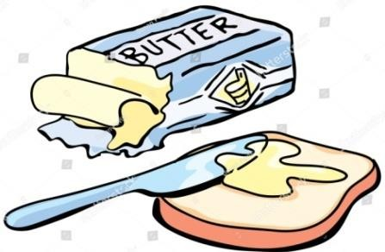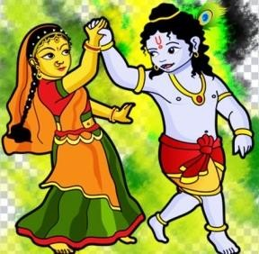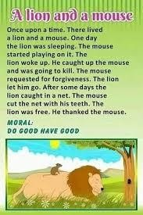
- Tooth brush activity worksheet (17.08.2022)
- Janamashtami celebration (18.08.2022)
- Shape sorting (19.08.2022)
- Colour the Hen using cotton (22.08.2022)
- Making of alphabets with ice cream sticks (23.08.2022)
- Bread jam activity (24.08.2022)
- Colour sorting activity (26.08.2022)
- Hopscotch game (alphabets recognition) (30.08.2022)

STORY TIME:

