NATIONAL UNITY DAY
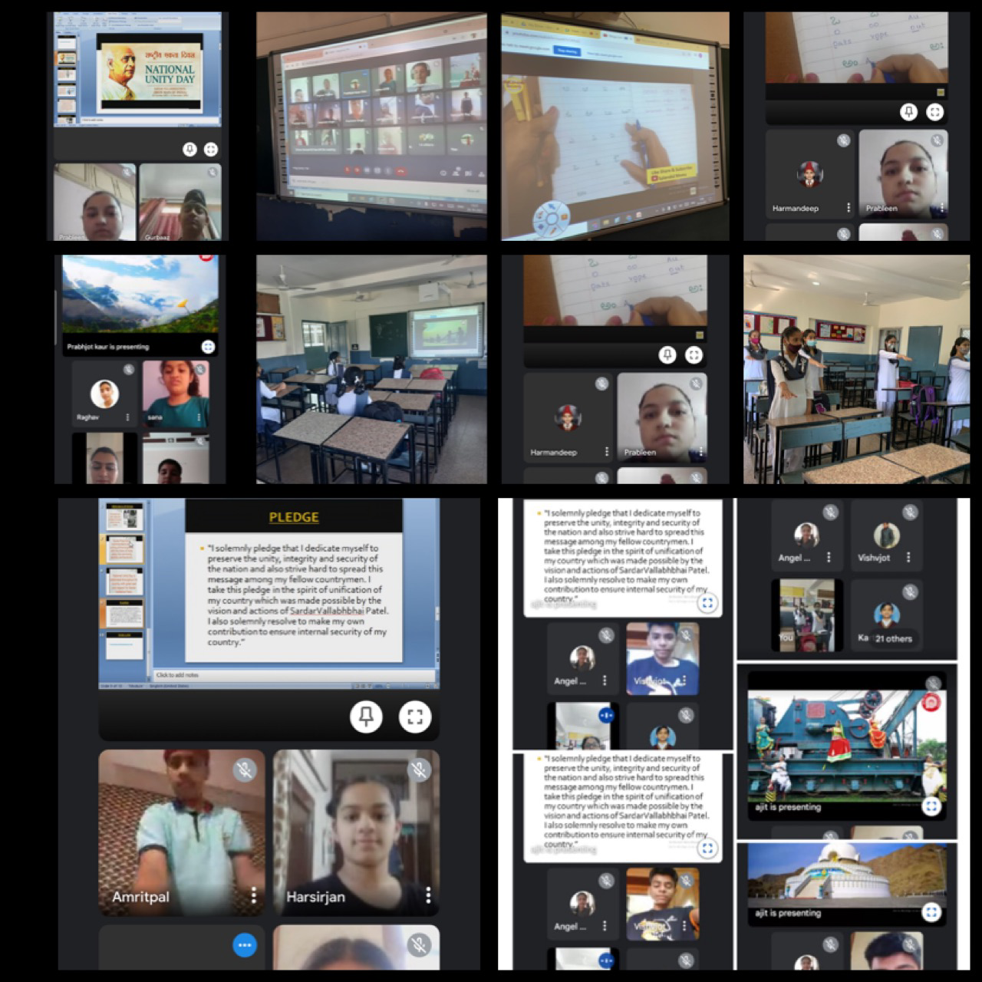
The importance of staying united in every situation is emphasized through the proverb – Unity is Strength. This has been used as a motto for various organizations as well as missions across the globe. National Unity day (also known as Rashtriya Ekta Diwas) is celebrated every year on 31st of October by the people throughout India. The day is observed to commemorate the efforts of Sardar Vallabhbhai Patel in the integration of post independence Indian dominion. National Unity Day was also celebrated in Shivalik Public School, phase -VI, Mohali where students were shown different alphabets of Andhra Pradesh and Punjab. Formation of these alphabets and their pronunciation was also taught to them. A PPT on the contribution of Vallabhbhai Patel was also shown to the students. They were also encouraged to take a pledge on Ekta Diwas to induce the spirit of unification in them. A song ‘ Mile Sur Hamara Tumhara’ highlighting the importance of unity was also played in both the languages I.e. HIindi and Telugu keeping in mind the theme Ek Bharat Shreshtha Bharat to evoke patriotic pride in the students.

