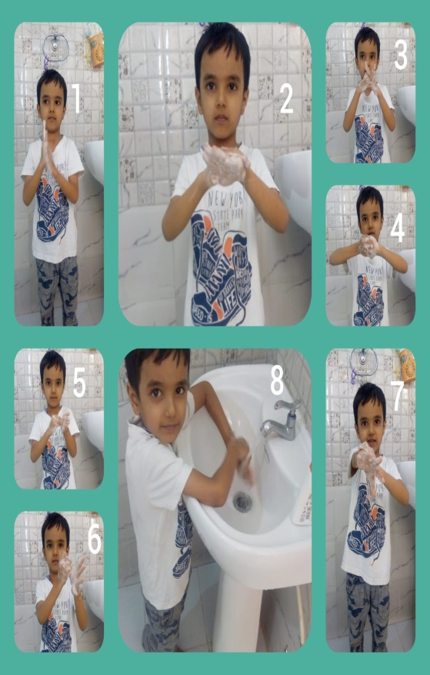
NATIONAL CHILD HEALTH DAY
The students of class I and II of Shivalik Public school Mohali celebrated National Child health day with great zeal. A demonstration on how to wash hands in 7 steps was given in online classes . A video on hygiene etiquettes to fight against corona virus and a PowerPoint presentation on healthy habits were shown to the kids. Children drew the pictures of their favourite healthy food items. It was a unique experience for the students.
Principal (Mrs Anup Kiran Kaur) appreciated the efforts of the students and highlighted the significance of good health and well being.
Children are the most important part of our society. Knowing how to best ensure their health secures our future for a bright tomorrow. The next generation need to develop
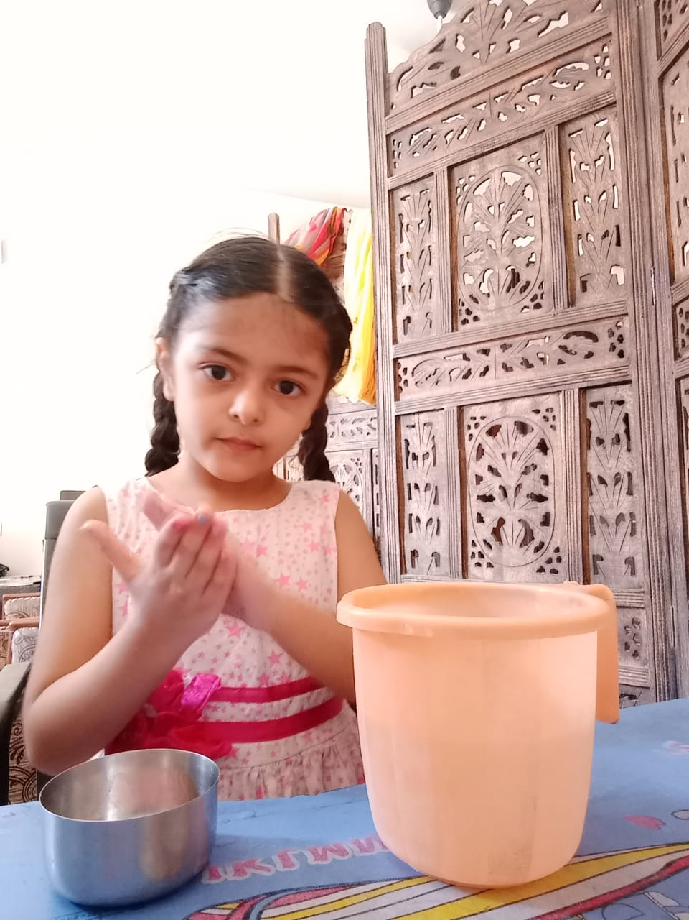
good health standards and it starts with us

