EK BHARAT-SHRESHTHA BHARAT REPORT
As we are aware that the idea of a sustained and structured cultural connect between people of different regions was mooted by Hon’ble Prime Minister of India during the Rashtriya Ekta Divas (31st October, 2015) on the occasion of birth anniversary of Sardar Vallabhbhai Patel to celebrate cultural diversity through mutual interaction and reciprocity between people of different States and UTs. Towards achieving this, every State and UT in the country has been paired with another State and UT for a year, during which they would carry out a structured engagement with one another in the spheres of language, literature, cuisine, festivals, cultural events, tourism etc.
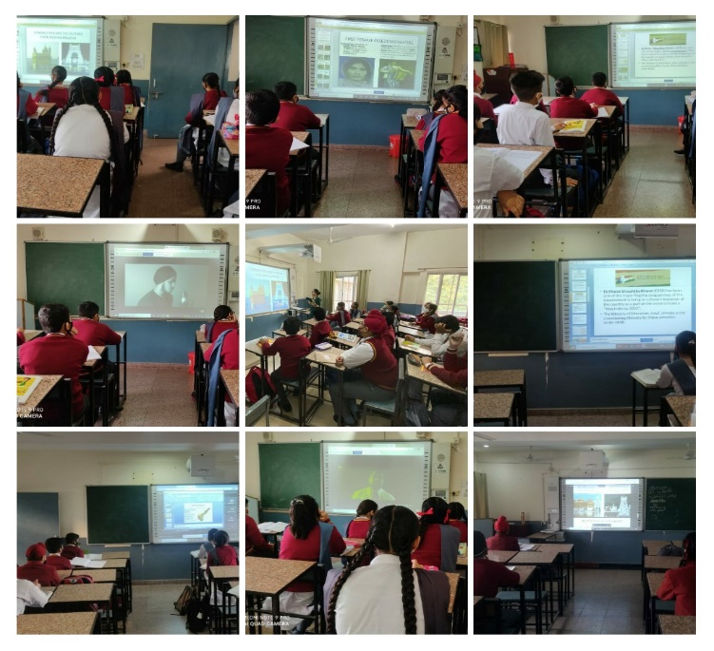
Shivalik Public School, Phase – VI Mohali, observed a symbolic statehood day of Punjab and Andhra Pradesh on 01.11.2021 under Ek Bharat-Shreshtha Bharat (EBSB) programme. Students were shown the PPT in which formation day of both the states was discussed with the students. They were informed about different alphabets ,crops grown, traditional cuisines, important rivers, dances forms , famous temples, famous crafts, indigenous sports, and female freedom fighters of both the states. The activity was concluded by playing the song ‘Teri Mitti Mein Miljava’ in both Hindi and Telugu language.

