SHIVALIK PUBLIC SCHOOL, MOHALI
PLANNER FOR THE MONTH OF DECEMBER- 2023
CLASS - NURSERY

ENGLISH-(WORLD OF LETTERS)
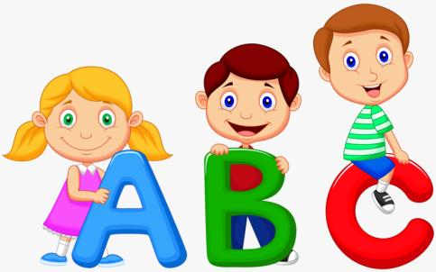
- Meet the letter Ss (Page No.60-61)
- I know N to S (Page No.62)
- Meet the letter Tt (Page No.64-65)
- Meet the letter Uu (Page No.66-67)

RHYME
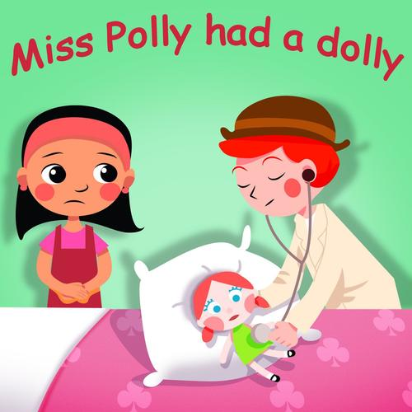
Miss Polly had a dolly who was sick, sick, sick
and she called for the doctor to come quick, quick, quick.
The doctor came with his bag and his hat
and he knocked at the door with a rat-a-tat-tat.
He looked at the dolly and he shook his head
and he said, "Miss Polly, put her straight to bed"
He wrote on a paper for a pill, pill, pill
I'll be back in the morning if the baby's still ill.
DRAWING BOOK
- Colour in ‘A Top’(Page No.23)
- Colour in ‘Clouds’(Page No.24)

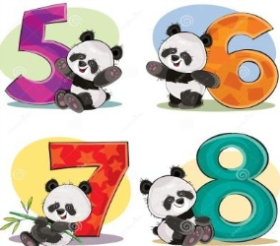
MATHS
- 8 Children in the bus (Page No.58-60)
- More and less (Page No.61)
- 9 Clever pigeons (Page No.62-64)
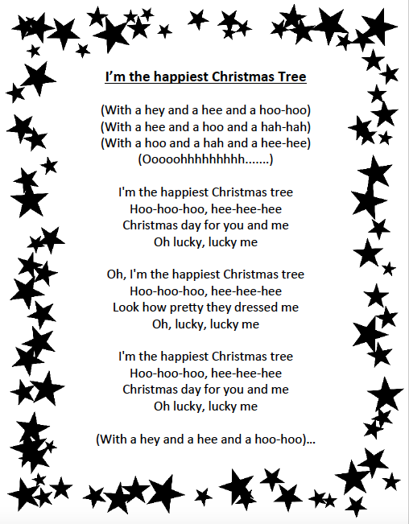
EVS
- Means of Transportation
- Festival Christmas (Colouring in Christmas tree)
- Carol singing

G.K questions
Q1. Who is the Prime Minister of India?
Q2. What are the different modes of transport?

ACTIVITIES

PPt on Healthy food (08.12.23)
Canteen day (11.12.23)
Nature walk (13.12.23)
Count and tell (14.12.23)
Leaf painting (15.12.23)
Making of letters with ice-cream sticks (18.12.23)
Making of Santa claus (19.12.23)
Making of Christmas tree (20.12.23)
Celebrating Christmas(Gifts sharing) (22.12.23)

NOTE:- Students will come in red dress on 22 December 2023
- Winter Break 25.12.2023 to 09.01.2024.

