CHRISTMAS CELEBRATIONS
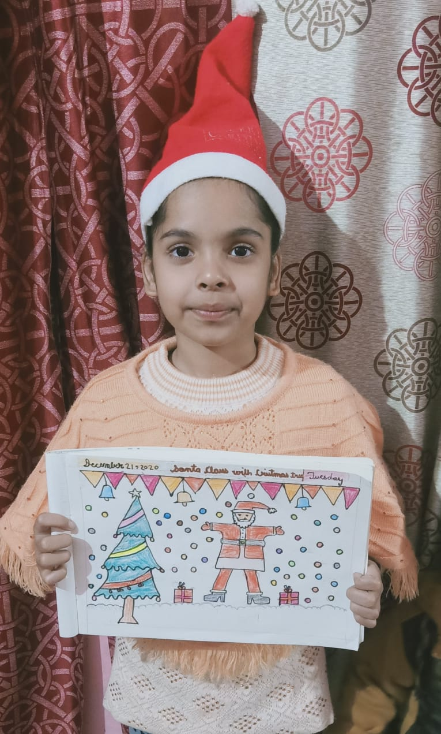
The tiny tots of classes 1 and 2 of Shivalik Public School celebrated Christmas with great fervor and enthusiasm. Several activities such as Drawing Santa and Christmas tree, Making a Christmas tree with origami and pastel sheets, Stockings, Santa caps and hand crafted bells were organized for the students. The children were told about the birth of Jesus Christ and the legend of Santa Claus. Special online assembly was also organized where students recited carols with full enthusiasm. The boundless joy of celebrating the festival was amply visible on the faces of the children. Principal Ms. Anupkiran expressed her delight on seeing such enthusiasm in the children who brought the spirit of Christmas to life.

