SHIVALIK PUBLIC SCHOOL,MOHALI CELEBRATES ITS FOUNDER’S DAY AND BAISAKHI
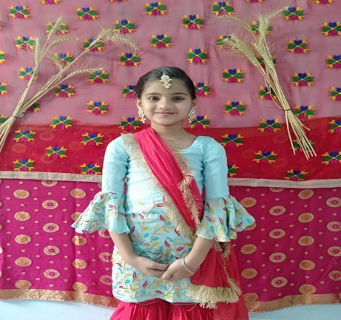
Shivalik Public School, Mohali celebrated Baisakhi and DR.B.R Ambedkar Jayanti with traditional fervor and gaiety. A special online assembly for classes (III-V) was conducted to mark the importance of Baisakhi. Assembly started with devotional songs, followed by speeches, poems and dances. To highlight the importance of the day the talk on Baisakhi was given and powerpoint presentation was presented.
Students were apprised with the golden memories of the past glorious 51 years of Shivalik Public School through the powerpoint presentation. Students of class-V presented a skit on Jallianwala Bagh Massacre.
The assembly concluded with a resplendent and energetic Punjabi folk dance performance. The aim behind the celebrations was to appraise the students of their rich culture and heritage.
Worthy principal, Mrs. Anupkiran Kaur congratulated the staff and the students mentioning that, Punjabi culture has a rich tradition and such festivals are the reasons that give us an opportunity to present the beautiful form of Punjab.

