Annual day” of the Kindergarten wing of Shivalik Public School, Mohali was Celebrated on 13th December 2023 which was woven around the theme “ODYSSEY” a musical journey, a cultural cornucopia that expresses the culture of our country. .
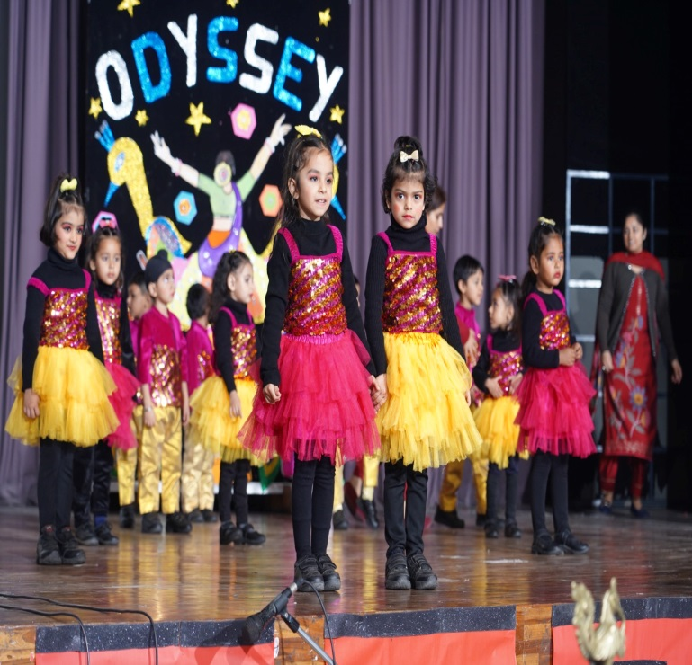
The Programme commenced with the lighting of the Ceremonial lamp by the Hon’ble Director of the School Shri D.S Bedi; Ms Gurkiran Jeet Nalwa, Educational Advisor and Principal, Shivalik Public School, Chandigarh ,was the guest of honour. Other dignitaries were Dr (Ms) Jyoti Soni, Principal, Shivalik Institute of Education and Research Mohali. Principal of the School , Dr. (Ms) Anupkiran Kaur welcomed the guests and shared the annual report highlighting the prominent features of the school, the achievements in academic and co- curricular activities for the year 2022-2023.
The cultural fiesta was marked by the series of exotic talents thus creating a festive mood.
The thematic show of talent ,imagination, and organization was a complete delight.
The synchronized dance movement to the foot tapping music cast a magical spell and the audience were enthralled by the well directed dance performances. The props and costumes added colour to the festive occasion , The show witnessed a hundred percent participation from the students .Medals were awarded to each participant for encouraging the young talent.
Addressing the gathering the Guest of Honour,
Ms Gurkiranjeet Nalwa, Educational Advisor and Principal of Shivalik Public School, Chandigarh stated that the students have smartly carved a niche for themselves . She said that the ideology of the school is to reach out to each child and ensure that each child is confident as well as aware and committed. She added that students should not only be imparted excellent education but also be given great scruple and values so they can effectively serve the nation.
The program concluded on a happy note with a grand finale dance performance by the tiny tots and staff.

