Annual Sports Meet
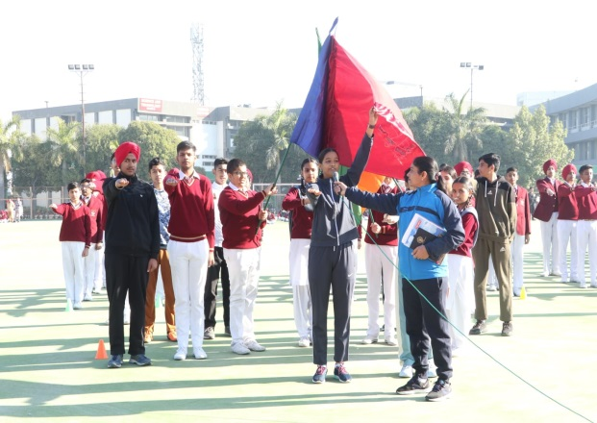
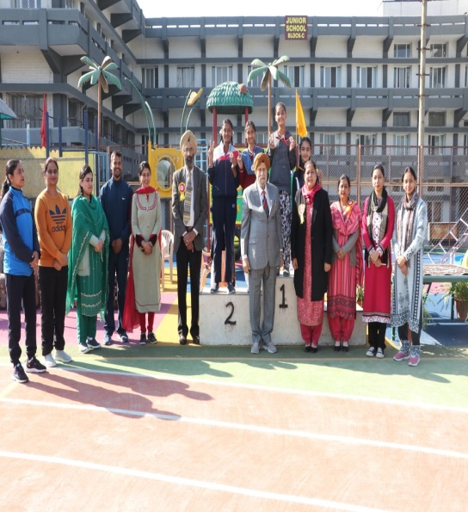
Shivalik Public School organized Annual Sports Meet in the School ground on 14 December 2022. The program commenced with the school Shabad and unfurling of the School flag followed by the March Past by the students of Class-IX. Mr. D.S. Bedi, esteemed Director of the school graced the occasion with his presence. Dr. Anupkiran Kaur, honourable Principal handed over the Sports torch to the Sports Captain, Hargun Kaur which was further passed on to the sports stars of the school- Daksh, Japveer, Harman, Jaivardhan and Tejas. With the Oath- taking, the Sports meet was declared open. Students of class VI-VIII showcased their vigour by performing Taekwondo and P.T. exercises. Some of the zealous events like Relay race, Shuttle race, Skipping race, Lemon and Spoon race, Sack race, Medicine Ball throw etc. were conducted. There was a fun Musical Chairs activity in which the teachers of the school participated. Participation certificates were awarded for the CBSE Cluster North Zone Volleyball Tournament to the players. In the prize distribution ceremony, medals were awarded to the winners by the esteemed Director, Mr D.S. Bedi. The meet was culminated by the Vote of thanks by Dr. Anupkiran Kaur, Principal and with the singing of the National Anthem.

